Pupil premium strategy statement – Bowerham Primary and Nursery School and Baby Unit

This statement details our school’s use of pupil premium funding to help improve the attainment of our disadvantaged pupils.
It outlines our pupil premium strategy, how we intend to spend the funding in this academic year and the outcomes for disadvantaged pupils last academic year.

School overview
Detail | Data
Number of pupils in school | 503 (87 in Nursery)
Proportion (%) of pupil premium eligible pupils | • PP – 102 pupils (20%)  • FSM – 85 pupils (17%)  • LAC – 16 pupils (3%)  • Service – 6 pupils (1%)
Academic year/years that our current pupil premium strategy plan covers (3-year plans are recommended – you must still publish an updated statement each academic year) | 2025-2026
Date this statement was published | December 2025
Date on which it will be reviewed | October 2025, February 2026, June 2026
Statement authorised by | Jo Banks
Pupil premium lead | Laura Hemingway
Governor / Trustee lead | Misbah Ashraf

Funding overview
Detail | Amount
Pupil premium funding allocation this academic year | £121,070 (Decrease of £28,450 from previous year)
Pupil premium funding carried forward from previous years (enter £0 if not applicable) | £0
Total budget for this academic year  If your school is an academy in a trust that pools this funding, state the amount available to your school this academic year | £121,070

Part A: Pupil premium strategy plan

Statement of intent
To effectively narrow the attainment gap for children in receipt of Pupil Premium funding, here are key strategies aligned with your school’s priorities and practices:
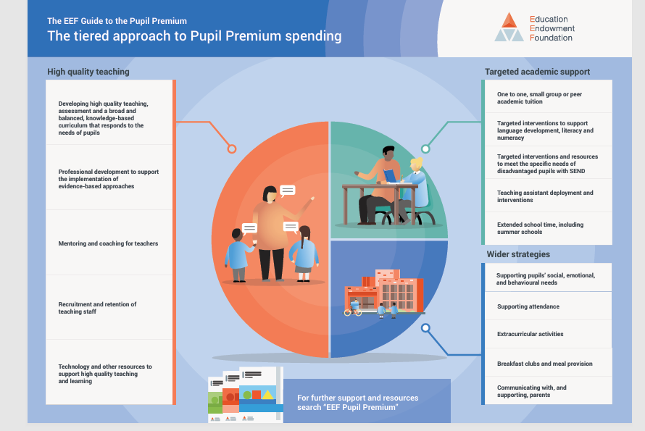
Our Vision: To effectively narrow the gap in attainment for children in receipt of Pupil Premium funding, ensuring their progress and achievement are in line with their non-Pupil Premium peers.
Our Aims: We aim to support all eligible pupils by:
- Ensuring high-quality teaching across the school that meets the needs of disadvantaged pupils.
- Implementing targeted interventions designed to accelerate progress and address gaps in learning.
- Providing enrichment opportunities that broaden pupils' experiences and support their social, emotional, and academic development.
- Delivering comprehensive pastoral care to ensure pupils feel safe, supported, and ready to learn.

Key Strategies for Improvement:
High-Quality Teaching:
  - Prioritise professional development for staff to enhance teaching strategies that support disadvantaged pupils.
  - Embed metacognitive approaches to develop pupils' thinking and reasoning skills.
  - Ensure clear curriculum planning identifies essential knowledge and builds on prior learning to secure progress.
Targeted Academic Support:
  - Implement evidence-based interventions tailored to individual pupil needs.
  - Use assessment data rigorously to identify gaps and track progress.
  - Provide additional tutoring and small-group interventions for pupils who require further support.
Enrichment and Pastoral Support:
  - Offer a range of enrichment activities, including sports, arts, and outdoor learning, to boost confidence and engagement.
  - Develop the school's indoor and outdoor SEN provision to enhance social skills and support children in achieving their EHCP and ILP targets.
  - Maintain robust safeguarding practices and provide pastoral support to address emotional and well-being needs.
Monitoring and Evaluation:
- Conduct regular assessment reviews to track progress and adapt interventions as needed.
- Use pupil voice to assess the impact of strategies on learning and well-being.
- Maintain close communication with parents and carers to ensure collaborative support.
Success Criteria:
- Improved attainment and progress outcomes for Pupil Premium pupils, closing the gap with non-Pupil Premium peers.
- Increased engagement in learning and school life.
- Enhanced emotional well-being and resilience, enabling pupils to thrive academically and socially.

By adopting this comprehensive approach, Bowerham Primary and Nursery School and Baby Unit are committed to ensuring that every child, regardless of background, receives the support they need to achieve their full potential.

Challenges
This details the key challenges to achievement that we have identified among our disadvantaged pupils.
Challenge number | Detail of challenge
1 | Gaps in vocabulary, reading fluency and writing stamina, particularly KS1 & KS2
2 | Learning and developmental needs including SEND, SALT and complex needs
3 | Limited cultural capital and narrow experiences impacting writing & reasoning
4 | Attendance, punctuality and inconsistent home learning routines
5 | Emotional well-being, confidence and behaviour vulnerabilities
6 | Parental engagement variability, multi-agency involvement and low priority placed on education
7 | High screen use, sleep disruption and reduced real-world interaction
8 | Limited family capacity due to disadvantage, thresholds for service support rising

Intended outcomes
This explains the outcomes we are aiming for by the end of our current strategy plan, and how we will measure whether they have been achieved.
Intended outcome | Success criteria
PP pupils attain in line with peers across core subjects | Gap narrows in reading, writing and mathematics
Targeted pupils make accelerated progress | Data shows improved trajectory term-on-term
Increased engagement and confidence | Improved participation and pupil voice feedback
Improved emotional well-being | Reduction in safeguarding, attendance and SEMH concerns
Families confidently support learning | Parent engagement increases, workshop attendance improves
Nursery pupils enter school closer to age-related expectations | GLD gap reduces year-on-year

Activity in this academic year
This details how we intend to spend our pupil premium funding this academic year to address the challenges listed above.

Teaching (for example, CPD, recruitment and retention)
Budgeted cost: £54,000
Activity | Evidence that supports this approach | Challenge number(s) addressed
Improved attainment and progress for Pupil Premium pupils, closing the gap with non-Pupil Premium peers  Prioritise professional development for staff to enhance teaching strategies that support disadvantaged pupils. | Research shows that high-quality teaching disproportionately benefits disadvantaged pupils. | 1, 2, 3
. To ensure a strong foundation for children at the start of their learning journey  Fund nursery fees in addition to 15 hours universal from 9 months or 2-year-old funding to support families in need.  Staff training – interactions/role of the adult, language development  Parental workshops alongside child/ren- to increase parental confidence and knowledge  Wellcomm assessments and referrals to SALT- with appropriate interventions in place | Vocabulary size relates academic success. EYFS is crucial for increasing breadth.  Parental engagement has a significant impact on pupil progress and outcomes | 1,2

Targeted academic support (for example, tutoring, one-to-one support, structured interventions)
Budgeted cost: £48,000
Activity | Evidence that supports this approach | Challenge number(s) addressed
Accelerated progress through targeted interventions. Implement evidence-based interventions tailored to individual pupil needs | Proven impact of tailored interventions on pupil progress | 1,2,3
To support a continued and successful learning journey for PCLA and Service children All PCLA to have a PEP to monitor their academic, social and well-being progress ensuring that support and intervention are at the point of need | Evidence shows that tracking progress and well-being can support each child | 1,5,6
Develop indoor and outdoor SEN provision to enhance social skills and support EHCP and ILP targets. | Evidence supports sensory and social spaces for promoting well-being and positive behaviour. | 1, 2,6,8

Wider strategies (for example, related to attendance, behaviour, wellbeing)
Budgeted cost: £44,000
Activity | Evidence that supports this approach | Challenge number(s) addressed
Increased engagement and confidence in learning Provide enrichment activities such as sports, arts, and outdoor learning and trips including residentials | Studies highlight the link between enrichment and improved self-esteem, resilience, and academic success. | 1, 5
Improved emotional well-being and readiness to learn. Home learning resources- lending library bags, PSED resources etc. | Strong evidence shows that Social and Emotional Learning (SEL) interventions significantly benefit children—especially those from disadvantaged backgrounds.  The Education Endowment Foundation (EEF) reports that SEL approaches lead to an average of +3 months’ progress and improve self‑management of emotions, social interaction, and overall well‑being.  The Partnership for Children guidance on Pupil Premium highlights that SEL-focused strategies are especially important for disadvantaged pupils, who often show weaker SEL skills and benefit disproportionately from approaches that support emotional well‑being. | 1,4,7
Strong safeguarding and pastoral support Maintain robust safeguarding practices and deliver tailored pastoral support. | Research highlights the importance of emotional security in enabling academic success. | 1,3,4,5,6,8

Total budgeted cost: £146,000

Part B: Review of the previous academic year 25.26

Outcomes for disadvantaged pupils
Bowerham’s Attendance
FSM attendance was 94% compared to 92.2% nationally (Y1 - 6 data – School’s Attendance Summary Report).
KS2 (Y6 SATs)
50% of disadvantaged pupils achieved Expected+ in Reading, Writing and Maths combined compared to 49% nationally (2026).
64% of disadvantaged pupils achieved Expected+ in Reading compared to 63% nationally (2025).
64% of disadvantaged pupils achieved Expected+ in Writing compared to 59% nationally (2025).
50% of disadvantaged pupils achieved Expected+ in Maths compared to 61% nationally (2025).
Y4 MTC
The disadvantaged mean scoring full marks was 19.4% compared to 19.4 nationally (2025).
38.5% of disadvantaged pupils scored maximum marks compared to 24.9% in Lancashire (2025 – national not available).
Y1 Phonics Screening Check disadvantaged
57% of disadvantaged children met the expected standard compared to 68% nationally (2026).
EYFS Good Level of Development (GLD)
89% of disadvantaged children achieved a GLD compared to 52% nationally (2025).

Externally provided programmes
Please include the names of any non-DfE programmes that you used your pupil premium to fund in the previous academic year.
Programme | Provider
N/A

