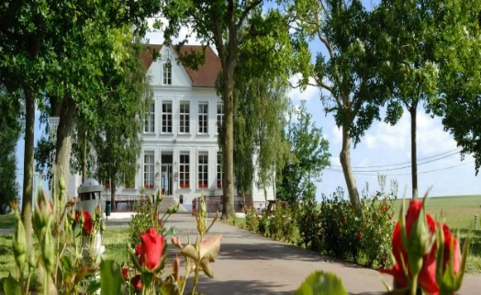
Chateau d’Ebblingham

Itinerary

Monday 7th September 2026
Evening | Entertainment on Centre
Tuesday 8th September 2026
Morning | Etaples Market Visit  Etaples Military Cemetery
Afternoon | Le Touquet Town Trail
Evening | Entertainment on Centre
Wednesday 9th September 2026
Morning | Activities at the centre with an early hot lunch then set off to Ypres and surrounding area
Afternoon | Bedford House Cemetery  Sanctuary Wood  Hill 60  Passchendaele
Evening | Packed tea provided by the centre Menin Gate & Last Post Ceremony where school will lay a wreath
Thursday 10th September 2026
Morning | D’Hardelot Biscuitiers
Afternoon | Local Town & Beach Visit
Evening | Entertainment on Centre
Friday 11th September 2026
Morning | Leave centre approx. 9.00am to catch ferry
Evening | Arrive at Bowerham School approx. 9pm

