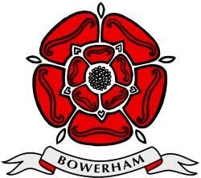
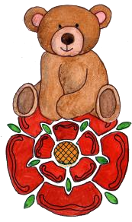
BOWERHAM PRIMARY & NURSERY SCHOOL & BABY UNIT

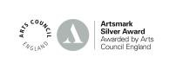
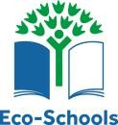
Bowerham Road, Lancaster, LA1 4BS
t: 01524 63999

www.bowerham.lancs.sch.uk
Headteacher: Mrs. Jo Banks
Assistant Headteachers: Miss Kathryn Ireland
Mrs. LauraHemingway Mrs. Jennie Gallagher
Office Manager: Mrs. Tracey Clark e: head@bowerham.lancs.sch.uk

Online safety 07/01/26
Dear Parents/Guardians,
It has recently come to our attention that a number of our Year 5 children are using the online gaming platform Roblox.
While we are aware that Roblox asks user for age verification to ensure features are restricted based on age, we ask that parents check these settings and appropriate filters are in place. Some aspects of the platform can expose children to inappropriate language, unsafe interactions, or privacy risks.
The NSPCC have published six tips to help keep your child safe on Roblox:
- Sign up with the correct age
Make sure your child creates an account using the correct age. On Roblox, certain safety settings and parental controls are enabled by default for children under 13. However, you should still review the settings to ensure they’ve been set up correctly.
- Build a list of age-appropriate games
Not all games on Roblox will be appropriate for your child. The platform has a setting that lets parents and carers limit what their child can play by allowing them to build lists of age-appropriate games. You can also switch off in-app spending or set them monthly limits.
- Explore communication settings
You can manage who your child can speak to by disabling chat completely or limiting it to friends only. You can also switch off their inbox to stop them receiving direct messages.
- Explore the platform together
Ask your child to give you a demonstration of the platform to help you understand how they use it and explore some of the parental controls together. You could even consider setting up your own account and playing the games yourself.
- Have regular conversations about gaming
Continue to have regular conversations with them about what they are doing online. Ask your child open questions like ‘What games have you been playing on Roblox recently?’ or ‘What platforms have you been using to play games?’.
- Check out our Online Safety Hub
Visit our Online Safety Hub for more advice and tips on gaming, talking to your child and much more. If you need more information on setting up parental controls on Roblox, visit their Parent Guide.
The school will continue to address online safety through PSHEE lessons and circle time, helping pupils understand how to use technology and online platforms in a kind, safe, and responsible manner.
Thank you for your continued support in reinforcing these important messages at home.
Yours sincerely,
The Online Safety Team

Stand tall, reach high, love learning
The Bowerham School community is proud to nurture aspiration, inspire love for life-long learning and prepare children for a changing
Society.

