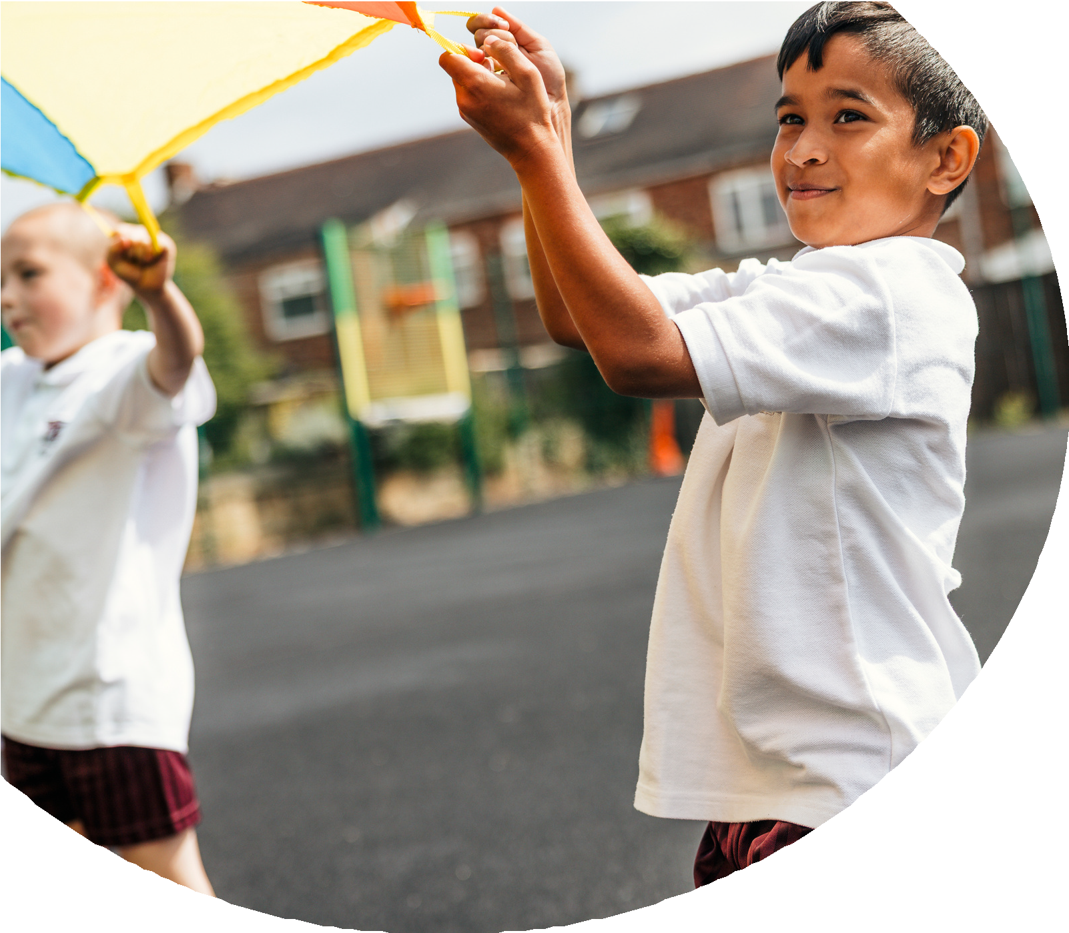
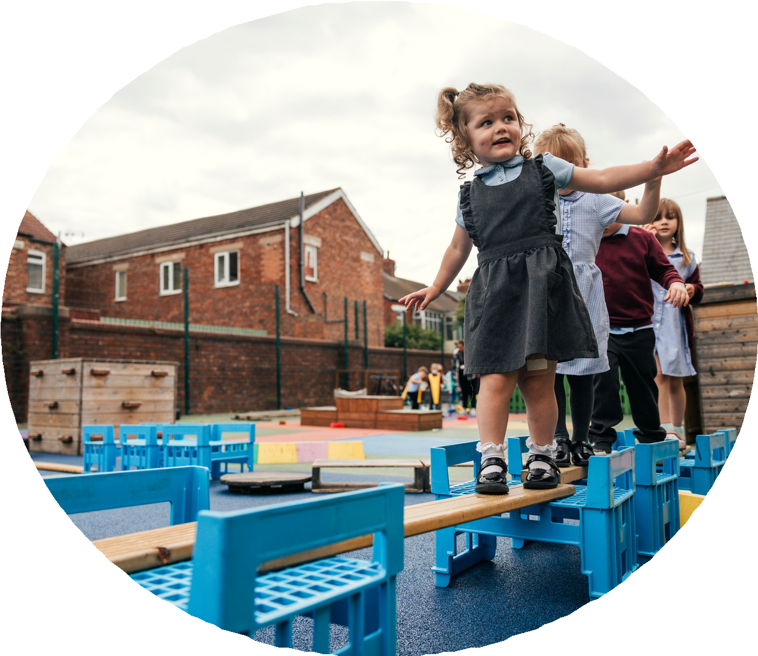

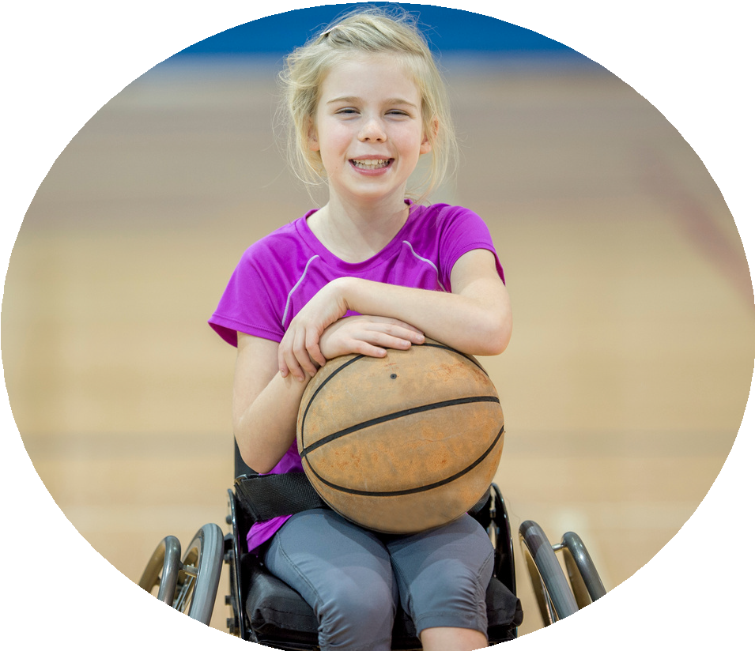



PE and sport premium monitoring and tracking form 2025/2026

Commissioned by

Created by


PE and sport premium monitoring and tracking form
- It is intended that this template should be used as preparation for the completion of the statutory DfE PE and sport premium digital expenditure reporting return. You can upload data (including swimming) from this template onto this platform once it becomes accessible.
- The template is a working document that you can amend and update during the year.
- Before you decide how you are going to use the funding for this academic year you should reflect and evaluate the impact of your use of you PE and sport premium funding in 2024/25.
- You should use your evaluation of last year’s funding to help you decide what to do this academic year, how you will do it, and what impact you expect it to have.
- All spending of the funding must conform with the terms outlined in the conditions of grant
- The summative digital expenditure reporting from June 2026 will continue to include swimming and water safety information. PE and sport premium funding can be used to provide top-up lessons, where necessary, to ensure pupils meet national curriculum swimming requirements
- To ensure funding is used effectively and based on your school’s needs; guidance and examples of best practice across schools can be found here.
- You must use the funding to make additional and sustainable improvements to the PE and sport in your school.
- You must develop and add to the PESSPA activities that your school already offers.

Useful Links:
- PE and sport premium for primary schools - GOV.UK
- PE and sport premium: conditions of grant 2025 to 2026 - GOV.UK
- It is intended that this template should be used as preparation for the completion of the statutory DfE PE and sport premium digital expenditure reporting return. You can upload data (including swimming) from this template onto this platform once it becomes accessible.
- The template is a working document that you can amend and update during the year.
- Before you decide how you are going to use the funding for this academic year you should reflect and evaluate the impact of your use of you PE and sport premium funding in 2024/25.
- You should use your evaluation of last year’s funding to help you decide what to do this academic year, how you will do it, and what impact you expect it to have.
- All spending of the funding must conform with the terms outlined in the conditions of grant
- The summative digital expenditure reporting from June 2026 will continue to include swimming and water safety information. PE and sport premium funding can be used to provide top-up lessons, where necessary, to ensure pupils meet national curriculum swimming requirements
- To ensure funding is used effectively and based on your school’s needs; guidance and examples of best practice across schools can be found here.
- You must use the funding to make additional and sustainable improvements to the PE and sport in your school.
- You must develop and add to the PESSPA activities that your school already offers.

Useful Links:
Complete the PE and sport premium expenditure reporting return - GOV.UK
PE and sport premium for primary schools - GOV.UK
PE and sport premium: conditions of grant 2024 to 2025 - GOV.UK

Review of the last academic year (2024/2025)

Swimming and Water Safety | What went well? Supporting evidence? | What didn't go well? Supporting evidence?
1. Swim competently, confidently and proficiently over a distance of at least 25 metres | 46 % increase in children able to swim competently, confidently and proficiently over a distance of at least 25 metres from the previous 2023/2024 year.  Children who were not competent in Y5 had extra lessons to support them in becoming secure with this skill. | Even with a large amount of progression we still strive to close the gap even further this year and get as close as we can to every child being a competent swimmer over at 25 metres.
2. Use a range of strokes effectively (for example, front crawl, backstroke and breaststroke) | 43% increase in children able to use a range of strokes effectively (for example, front crawl, backstroke and breaststroke) from the previous 2023/2024 year.  Children who were not competent in Y5 had extra lessons to support them in becoming secure with this skill. | Even with a large amount of progression we still strive to close the gap even further this year and get as close as we can to every child being a competent swimmer by using a variety of strokes.
3. Perform safe self-rescue in different water-based situations | With an increase in the swimming ability and skills data. This area appears to have decreased in children securing this goal, this must be a focus for the 2025/2026 year. | A 18% decrease in children that can perform safe self-rescue in different water-based situations compared to the 2023/2024 year.
- Take some time to reflect on your intent, implementation and impact from last academic year to celebrate your wins but to also think about improvements for the year ahead.
- You do not need to complete every box. Just record the information that is key to your school's priorities and areas of focus.
Remember - Be clear about how you focussed spending on key groups such as SEND, girls and disadvantaged pupils.

Review of the last academic year (2024/2025)
Key areas as outlined in PE and sport premium guidance | What went well? Supporting evidence? | What didn't go well? Supporting evidence?
1. Increasing confidence, knowledge and skills of all staff in teaching PE and sporting activities prioritising CPD and training where needed | Internal staff CPD carried out by PE team for EYFS, KS1 and KS2.  External CPD for staff including PE updates conference and PE across the curriculum.  External coaches working alongside teachers during curriculum PE; upskilling PE teaching and increasing confidence when teaching PE.  Teachers working alongside professional coaches across a wide range of sports during ‘Bowerham’s Summer of Sport.’ Again, this provided teachers with more skills and confidence across a wider range of sports. | More CPD training required for specific area of weakness such as gymnastics or fundamental movement skills.
2. Increasing engagement of all pupils in regular physical activity and sporting activities | - All competitions offered through SSN and Lancaster Schools have been entered including new competitions such as Cross Country as well as SEN competitions.  - Continued success in events, winning athletics qualifier and therefore attending Lancashire Schools Competition, winning Boy’s Easterfield, winning netball qualifier to attend Lancashire Schools Competition.  - More events attended for lower KS2 children.  - New competition events entered such as Handball and Benchball. | KS1 competitive sports experiences.  Competitive experiences for all children across KS1 and KS2.
3. Raising the profile of PE and sport across the school, to support whole school improvement | Certificates awarded and sports round ups in celebration assemblies.  Sports evening dedicated to all children’s involvement, progress, effort and success in sport.  Regular sports council meetings.  Sports council notice board in main hall.  Extra curricular sports clubs offered throughout the year for KS1 and KS2 including expert coaching by external coaches. | - More opportunities needed for girls to play sports independently from boys.
4. Offer a broader and more equal experience of a range of sports and physical activities to all pupils and ensure equal access to sport for boys and girls | - We have entered all participation events including those for SEN and PPG children.  A large range of extra curricular activities offered across KS1 and KS2.  Celebration of sporting events to give girls extra experiences such as girls football day.  Summer of Sport – offering a wider range of sports including crown green bowls and skateboarding to name a few.  - All competitions offered through SSN and Lancaster Schools have been entered including new competitions such as Cross Country as well as SEN competitions.  - 60 active minute activities to be expanded. For example, quick games that have already been taught in PE curriculum lessons. This will ensure skills are being developed as well as tactical skills and physical activity.  - Entered all competitions for girls including cricket, football and netball. | More intra-school competitions could be held in a wider range of sports to add greater depth to our existing extra curricular clubs with a focus on children who come from disadvantaged backgrounds.
5. Increasing participation in competitive sport | - All competitions offered through SSN and Lancaster Schools have been entered including new competitions such as Cross Country as well as SEN competitions.  - Continued success in events, winning athletics qualifier and therefore attending Lancashire Schools Competition, winning Boy’s Easterfield, winning netball qualifier to attend Lancashire Schools Competition.  - More events attended for lower KS2 children.  - New competition events entered such as Handball and Benchball. | No Intra school competitions held which could increase the participation in competitive sport for all children.

Aims for the next academic year (2025/2026)
- Using your whole school priorities, school development plan and previous PE, school sport and physical activity data, set out your aims for the year ahead.
- Think about specific areas of need such as inactive girls, SEND and disadvantaged pupils
- Remember to also input your swimming data and reflections in the table located at the bottom of this page.
- Consider which of the 5 key areas improvements will be focussing on:
- Increasing confidence, knowledge and skills of all staff in teaching PE and sporting activities prioritising CPD and training where needed.
- Increasing engagement of all pupils in regular physical activity and sporting activities
- Raising the profile of PE and sport across the school, to support whole school improvement
- Offer a broader and more equal experience of a range of sports and physical activities to all pupils and ensure equal access to sport for boys and girls
- Increasing participation in competitive sport
Swimming and Water Safety | Input data | Reflections
1. Swim competently, confidently and proficiently over a distance  of at least 25 metres |  | Even with a large amount of progression we still strive to close the gap even further this year and get as close as we can to every child being a competent swimmer over at 25 metres.
  47/58 81% | 47/58 81%
2. Use a range of strokes effectively  (for example, front crawl, backstroke and breaststroke) | 47/58 81% | Even with a large amount of progression we still strive to close the gap even further this year and get as close as we can to every child being a competent swimmer by using a variety of strokes.
3. Perform safe self-rescue in different water-based situations | 38/58 66% | A 18% decrease in children that can perform safe self-rescue in different water-based situations compared to the 2023/2024 year.

Aim | Why? | Key area | Supporting evidence
Complete a new round of CPD for PE – monitor with staff questionnaires and feedback. | To coniually check staff confidence and assess any areas which could be improved. | Across all areas of school. | Lesson observations/discussions  Staff questionnaires.
Continue to enter all participation events including SEN and PPG children. | To continue our whole school focus of being an active school and provide children with a full range and opportunity of sporting events. | KS2 external competitions.  KS1 and KS2 intra school competitions. | Calendar of dates for all school competitions entered.  Timetable of intra school competitions.
Focus on intra school competition (for disadvantaged children) each half term. To build confidence in sport or find a passion of a new sport. | To give all children a chance to try a new sport and to be involved in competitive sporting opportunities. | KS1 and KS2 | Timetable of intra school competitions.
60 active minute activities to be expanded. For example, quick games that have already been taught in PE curriculum lessons.  Athletics skills/events focus throughout all phases of school to be implemented during 15 min exercise time.  Current timings (active 60 mins) –  break 10:25-10:40 = 15 min  Lunch = 30 mins  Timetabled exercise time MUST total 15 minutes. | This will ensure skills are being developed as well as tactical skills and physical activity. | EYFS, KS1 and KS2 | PE team to timetable focuses.
PE passport feedback/changes for next academic year. | Teachers are up to date with any changes. New classes and pupils added. | EYFS, KS1, KS2 | KW attended a PE passport update CPD.  New updates sent out via teams.
An increased focus on children to perform safe self-rescue in different water-based situations. | A 18% decrease in children that can perform safe self-rescue in different water-based situations compared to the 2023/2024 year. | Y5/Y6
Aims for the next academic year (2025/2026)
As above.

Plan, monitor and evaluate (2025/2026)
- Please aim to use this as a live working document through the year.

- Keep returning to this to evidence adaptations and progress made through the PESSPA opportunities you provide.

- There is no set number of objectives you must have.

- Make as many or as few as you see fit that will support your aims for the year ahead.

- Consider which of the 5 key areas improvements will be focussing on:
- Increasing confidence, knowledge and skills of all staff in teaching PE and sporting activities prioritising CPD and training where needed.
- Increasing engagement of all pupils in regular physical activity and sporting activities
- Raising the profile of PE and sport across the school, to support whole school improvement
- Offer a broader and more equal experience of a range of sports and physical activities to all pupils and ensure equal access to sport for boys and girls
- Increasing participation in competitive sport

Plan, monitor and evaluate (2025/2026)
PE Grant for 2025 - 26
 | Intent – what is your objective? | Implementation - How will you achieve this? | Impact - What do you hope to see? | Supporting evidence
Plan and monitor | Develop lunchtime play provision to increase activity for least active groups. | Develop pupil leadership (training programme), Midday supervisor training, Staff CDP to develop their understanding of games and play, Range of equipment, Youth voice activities to understand pupils wants and needs Outdoor play provision such as OPAL | A confident and competent group of activity leaders that take initiative and create a more active and inclusive playground for all pupils. Midday supervisors and all staff leading a range of physical activities and joining in with movement daily to role model. A happier, more active playground that meets the needs of all pupils especially SEND and girls. | Youth voice data through half-termly surveys and interviews/group discussions with a variety of pupils (leaders, children participating and those that are less active at break times). Conduct regular observations of the playground to gauge activity levels of the least active children. Staff voice and feedback
 | What impact have you seen? | Are the improvements sustainable? How? | Supporting evidence | Approx. cost
Evaluate | Activity leaders are leading a broad range of activities and actively seeking children that are not engaged in physical activity during lunch times. Midday supervisors have grown in confidence and far more active and engaged in games with the children. Lunch times are more active with children having fun. Activity options have been tailored to suit the needs of SEND pupils through considerate choices of equipment and the types of games played. Girls are proving to be the hardest group to engage as some are still choosing not to be active | Continued training for activity leaders and bringing new leaders into the group to bring new ideas and expertise. More leaders will also mean more activities are able to be delivered. Continued training with midday supervisors. Establish lead midday supervisors to empower them and give them ownership. Continue to listen to SEND pupils and tailor activities to their needs and wants. Focus priorities on engaging girls. Work with least active girls to create activities that are meaningful and enjoyable for them. Do they want to be activity leaders for younger children to give them purpose and confidence? | 100 out of 100 activity leaders want to carry on with this role next year. 30 more children have enquired to joining the team. Meetings and the end of year survey have shown all leaders feel positive and enjoy making a difference for others. Interviews by random selection were conducted and 92% of pupils were either 'happy' or 'very happy' with the activities on offer at lunch time. End of year physical activity survey findings such as:  - Am I involved with games at lunch time - 89% Yes  - Do I enjoy lunch time? 97% Yes  - Have I joined in with a game with the activity leaders? 100% Yes | Physical Resources - £1000  CPD for staff - £500  OPAL - £8000
Your Objective: Further PE CPD opportunities for staff.

 | Intent – what is your objective? | Implementation - How will you achieve this? | Impact - What do you hope to see? | Supporting evidence
Plan and monitor | Complete a new round of CPD for PE – monitor with staff questionnaires and feedback. | Lesson observations/discussions.  Staff questionnaires.  Specialised coach to work alongside staff. | Increase in confidence and knowledge across all staff.  Further enjoyment and development of PE skills through specialised coaching and a varied range of activities. | LB – booked onto Gymnastics CPD course (November).  Potential Royal Ballet all staff CPD.  In house staff training booked in for 4.02.26.
 | What impact have you seen? | Are the improvements sustainable? How? | Supporting evidence | Approx. cost
Evaluate |  |  |  | £11,400 (MS Coaching inc. ASC coaching costs).

Your Objective: inclusive opportunities for SEN and PPG children.

 | Intent – what is your objective? | Implementation - How will you achieve this? | Impact - What do you hope to see? | Supporting evidence
Plan and monitor | Continue to enter all participation events including SEN and PPG children. | To continue our whole school focus of being an active school and provide children with a full range and opportunity of sporting events.  Enter events through LHSSN | Opportunities for more children to compete at a range of events including SEN, PPG children. | All available competitions entered so far (12.10.25) including girls only events (football) and SEN and PPG events (Pentathlon and Teambuilding event).
 | What impact have you seen? | Are the improvements sustainable? How? | Supporting evidence | Approx. cost
Evaluate |  |  |  | Part of the LHSSN membership

Your Objective: Provide inclusive intra school competitions.
 | Intent – what is your objective? | Implementation - How will you achieve this? | Impact - What do you hope to see? | Supporting evidence
Plan and monitor | Focus on intra school competition (for disadvantaged children) each half term. To build confidence in sport or find a passion of a new sport. | Hold half termly competitions in school. | To build confidence in sport or find a passion of a new sport.  More opportunities in competitive sport for PPG children. | Timetabled events for the year.  First event booked – Duathlon 21/10/25  KS1 dodgeball completed (Autumn 2)  Table Tennis date tbc  Cross country dates tbc  Badminton date tbc
 | What impact have you seen? | Are the improvements sustainable? How? | Supporting evidence | Approx. cost
Evaluate | Opportunities for children to enjoy new sports. Children’s feedback from the duathlon and dodgeball was very positive with all children trying a new sport for the first time. |  |  | £4,000  New equipment costs  Dodgeballs  Table tennis tables and equipment  Badminton equipment  SEND PE Equipment  Upgrade of older equipment  £1,000 Sports kit

Your Objective: Specific activities for 60 active minutes.
 | Intent – what is your objective? | Implementation - How will you achieve this? | Impact - What do you hope to see? | Supporting evidence
Plan and monitor | 60 active minute activities to be expanded. For example, quick games that have already been taught in PE curriculum lessons.  Athletics skills/events focus throughout all phases of school to be implemented during 15 min exercise time.  Current timings (active 60 mins) –  break 10:25-10:40 = 15 min  Lunch = 30 mins  Timetabled exercise time MUST total 15 minutes. | Timetable these depending on upcoming events or skills we want children to upskill. | Children being upskilled in specific areas.  Enabling more success in individual and team competitions. | To be implemented during staff meeting (04.02.2026)
 | What impact have you seen? | Are the improvements sustainable? How? | Supporting evidence | Approx. cost
Evaluate

Your Objective: Improve swimming data for self rescue.

 | Intent – what is your objective? | Implementation - How will you achieve this? | Impact - What do you hope to see? | Supporting evidence
Plan and monitor | An increased focus on children to perform safe self-rescue in different water-based situations. | Continue with swimming lessons with year 5 children and support the Y6 children who are not secure.  Discussion focus on self-rescue with swim instructor. | An increase in children performing safe self rescue – matching the 81% swim that can swim 25m and perform a range of strokes effectively. | 2025/26 swimming lessons and transport booked.
 | What impact have you seen? | Are the improvements sustainable? How? | Supporting evidence | Approx. cost
Evaluate |  |  |  | £2010 (venue hire)  £1,800 (Swimming transport)

Your Objective: To provide enhanced sporting opportunities for all children.
 | Intent – what is your objective? | Implementation - How will you achieve this? | Impact - What do you hope to see? | Supporting evidence
Plan and monitor | To provide enhanced sporting opportunities for all children. | Bowerham Summer of Sport inc. specialist coaches for specific sports.  Crown green bowling  Cricket  Tennis  Karate  Assault Course  Dance  Skateboarding  Scooting  Enrichment opportunities throughout the year-  Climbing wall  Table tennis  Duathlon  Swimming Gala | An increased love for sport, children to try new sports, specialised coaching to have an impact on children’s ability of performance. | Contact details for sports which have been booked in previous years to be contacted in Spring ready for Summer.
 | What impact have you seen? | Are the improvements sustainable? How? | Supporting evidence | Approx. cost
Evaluate |  |  |  | £10,000 coaches, equipment, venue hire, transport.

