
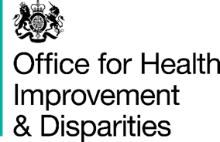

National Dental Survey: Information for parents and persons with parental responsibility

Why is there a dental survey?

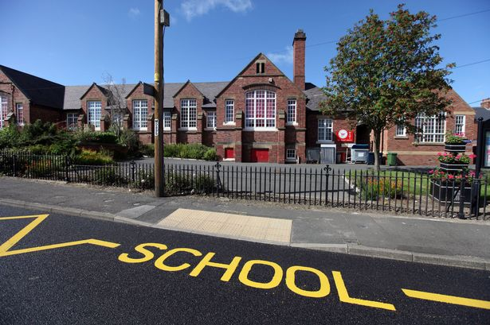

Every year we collect information on the health of peoples’ teeth. This is called a dental survey. The information helps to plan NHS dental services in your area.

This year the survey is collecting information about the health of the teeth of 5-year-old children. You are being asked to agree to your child taking part in the dental survey on Wednesday the 28th of January 2026.

What does the survey involve?

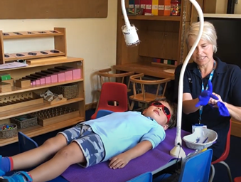
If you agree, a dental team will have a quick look at your child’s teeth at their school. This only takes a few minutes. New gloves and clean mirrors will be used for each child. No treatment will be provided.

You can come along if you like. Your child will not be forced to have a check if they do not want to.



This does not replace your child’s regular dental appointments. You should still take your child to these.


You can see a dental check at: https://youtu.be/BzrjK8HRpD8

If you are happy for your child to take part, please complete and sign the agreement form and return it to your child's school.


What information is collected?

Your child’s details are provided by their school to the dental team. These details include their name and date of birth. This is so we can check they are the right age and invite them to take part.


If you agree to your child taking part, the school will also provide your child's sex, ethnicity and postcode. These details will be linked to your child’s dental check. We use this to see if there are changes in children's dental health in different groups and different places where they live to understand patterns in dental health.

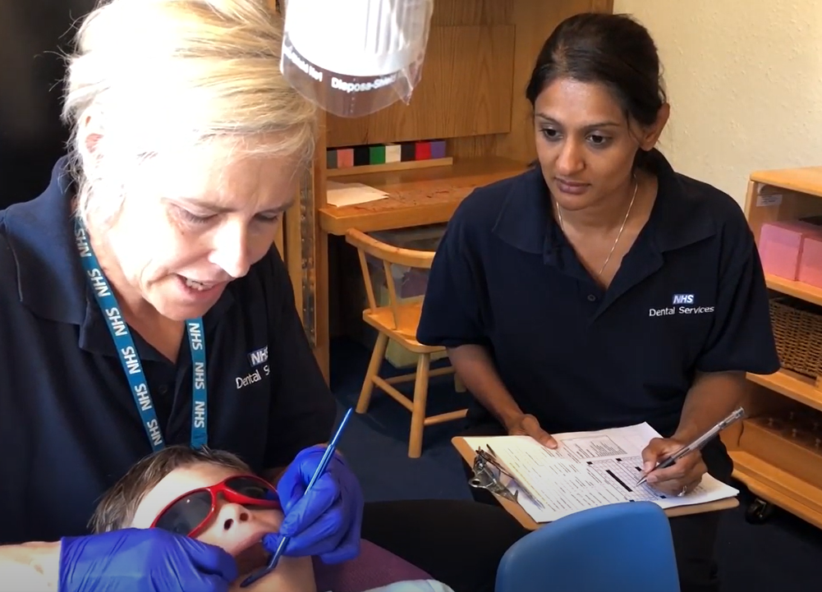
The information will then be sent safely to the Office for Health Improvement and Disparities.


What if the dental team finds a problem?

This is not like a full dental check-up. If we find something which needs a closer look we will let you know by letter.

What will the Office for Health Improvement and Disparities do with the information?


The Office for Health Improvement and Disparities works to improve health for everybody. The Department of Health and Social Care is the data controller for your child’s information.

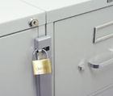
The details of the children who take part will be studied. A report will be written. Your child’s dental information may be linked to other health information about them. No information will be published that identifies your child.


Information about your child is kept securely:

• in files in our offices

• on our computers

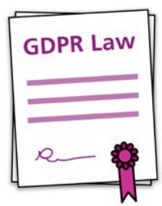
Under the General Data Protection Regulation, the lawful bases we rely on for using your child’s information are:

• we have a legal obligation

• we need it to perform a public task

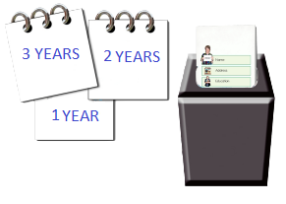
The information may be shared by the Office for Health Improvement and Disparities with other organisations, such as universities. Names, dates of birth and postcodes will be removed so that no child can be identified.

We keep your child’s details for 3 years then we will destroy it securely.

You can read about the Office for Health Improvement and Disparities at: https://www.gov.uk/government/organisations/office-for-health-improvement-and-disparities

Your rights

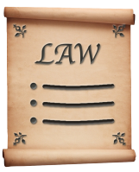
You can ask us to see the information we hold about your child.

You can ask us to make changes to information we hold about your child.

You can ask us to delete information about your child.

You can ask for copies of the information we hold about your child.

You can ask us to stop processing information about your child.

What if I have a question?


If you have a question about the dental survey, you can contact

dentalepidemology@lancashire.ac.uk or by writing to:

University of Lancashire Community Dentists Limited, Harrington Building, University of Lancashire, Preston, PR1 2HE

You can also contact the Office for Health Improvement and Disparities at:

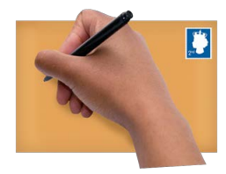
dentalphintelligence@dhsc.gov.uk or by writing to:

Dental Public Health
Office for Health Improvement and Disparities
Department of Health and Social Care 39 Victoria Street
London SW1H 0EU


If you have a question about how your child’s information is being used for the dental survey, you can contact:

data_protection@dhsc.gov.uk or by writing to:


Data Protection Officer
1st Floor North
39 Victoria Street
London SW1H 0EU

You can also contact the Information Commissioner’s Office by calling 0303 123 1113 or by live chat at ico.org.uk/make-a-complaint

