Art Curriculum

Art, Craft and Design at Bowerham
At Bowerham, we believe that art, craft and design education should ignite curiosity, nurture self-expression, and open doors to cultural understanding. It should inspire both creative and practical responses, encourage imaginative risk-taking, and equip pupils with the tools to respond thoughtfully to the material, emotional, social and digital worlds around them.
A world-class art, craft and design education engages, inspires and challenges. It empowers pupils to participate fully, to experiment boldly, and to invent and create with confidence. Through this journey, they develop the knowledge, skills and resilience needed to think both creatively and critically.
Our pupils explore and evaluate a wide range of creative outcomes from the past and present, building a deep understanding of the many disciplines within art, craft and design and recognising how these have shaped — and continue to shape — our history, culture and future. In doing so, they grow into confident citizens and future professionals, ready to contribute to the cultural, creative, economic and emotional well-being of our society on both a national and global stage.
The National Curriculum for Art and Design aims to ensure that all pupils:
- Produce creative work, exploring ideas and recording experiences.
- Become proficient in drawing, painting, sculpture and a range of other art, craft and design techniques.
- Evaluate and analyse creative works using the language of art, craft and design.
By the end of each key stage, pupils are expected to know, apply and understand the matters, skills and processes outlined in the programme of study.
- Matters: The essential knowledge needed to explore different media, develop technical skills, and inform creative actions through the study of artists, makers and designers from diverse cultures and eras.
- Skills: The progressive refinement and mastery of practical and technical abilities.
- Processes: The insight and understanding gained through direct teaching and active participation in creative sequences, design thinking, and the application of specific techniques.
Using Sketchbooks
We introduce sketchbooks in Year 3 as a personal record of each learner’s artistic journey—capturing work from curriculum units and providing space to explore, experiment, and develop ideas further. At Bowerham we encourage pupils to see their sketchbook as a safe space to take risks, make mistakes, and try out new techniques, building both confidence and creativity. It is also used to collect visual inspiration, jot down thoughts, and reflect on their own progress. Over time, the sketchbook becomes not only a record of learning but also a trusted companion for imaginative thinking and personal expression.
https://www.accessart.org.uk/sketchbooks-for-ages-3-11/

EYFS
In Reception, children develop their artistic and cultural awareness as part of the Expressive Arts and Design area of the EYFS framework. This supports the development of their imagination, creativity, and ability to communicate through art. Through a balance of continuous provision and carefully planned teacher-led activities, following a ‘Curiosity Approach’ format, children are encouraged to explore and experiment with a wide range of media and materials. These rich and varied experiences enable children to express their ideas and feelings, extend their vocabulary, and develop confidence in using different artistic forms such as drawing, painting and sculpting. The quality, variety, and frequency of these opportunities are fundamental to children’s progress in creating, responding to, and appreciating the world around them.
Key Stage 1
Pupils should investigate, explore, and begin to develop their understanding and control of simple techniques while engaging with the work of artists, craftspeople, architects, filmmakers, and designers. They should encounter examples from both local contexts and a wide variety of national, cultural, and industrial traditions.
Through creative, discursive, and practical activities, pupils should be taught:
- The knowledge, understanding, and skills needed to participate in a process of self-expression and personal response.
- A foundational understanding and technical skill in core processes, including drawing and mark-making, colour mixing and painting, forming, assembling/constructing and modelling, printing and pattern-making, and techniques such as cutting, tearing, sticking, and collaging.
Pupils should also learn to:
- Use a range of materials creatively to design and make products.
- Apply drawing, painting, and sculpture to express and share their ideas, experiences, and imagination.
- Develop a broad range of art and design techniques, exploring colour, pattern, texture, line, shape, form, and space.
- Study the work of artists, craft makers, architects, and designers, identifying similarities and differences between practices and disciplines, and linking these to their own work.
To support this, teachers should:
- Introduce and explore key features of selected works by significant artists, craft makers, architects, filmmakers, and designers, highlighting differences and similarities between practices and encouraging pupils to make connections to their own creative work.
- Use images, films, books, reproductions, websites, and original works in museums and galleries to foster reflection, analysis, comparison, speculation, imagination, questioning, and interpretation.
- Encourage pupils to share their developing views and ideas through discussion, using reading, speaking, and listening to inform their creative decisions and actions.
To assess progress, teachers should:
Assessment in art should be ongoing, conversational, and supportive, recognizing that creativity is fragile and difficult to quantify. Teachers can use questions to guide reflection and understanding during every lesson:
- Tell me about what you are making.
- What might you do next?
- Which materials might you use?
- What have you discovered?
- Tell me about what you have made.
- What would you like to explore more of?

Year 1

Key Concepts | - Children understand that drawing is expressive and physical, involving the whole body.  - They learn to control marks through tool grip, pressure, and movement.  - They begin to draw from observation, memory, and imagination.  - They explore the use of colour, shape, and line to engage and communicate ideas.  - They are introduced to sketchbooks as personal spaces for experimentation.  - They develop close looking skills and use drawing to observe the natural world.  - They experiment with collage, cutting, and mixed media to create individual and collaborative artworks.  - They explore the connection between 2D drawing and 3D making, transforming flat images into simple sculptures.  - They learn to take creative risks and value their unique ideas within group work.
Generating Ideas | Children will take pleasure in exploring artworks by artists, craftspeople, architects, and designers, noticing elements that inspire them. They will have time and space to connect with the physical world—through visiting, seeing, holding, and listening—to spark creative responses. When engaging with artworks or other stimuli, children will ask questions such as what they can see, what they like and why, how it makes them feel, and what they might ask the artist. Generate ideas through playful, hands-on exploration of materials, free from the constraints of a predetermined outcome.
 | Autumn  Drawing and Sketchbooks - Spirals | Spring  Surface and Colour – Flora and Fauna | Summer  Working in 3D – Making Birds
Key Vocabulary | - Spiral  - Pressure  - Motion  - Line  - Continuous drawing,  - Graphite, chalk, pen, oil pastel,  - Dark and light,  - Blending,  - Mark making  - Pattern | - Line  - Shape  - Colour  - Tone  - Hues  - Tints  - Graphite  - Oil pastel  - Collage  - Tear and cut  - Composition | - Texture  - Shape  - Blending  - Observe  - Transform  - Fold  - Tear  - Crumple  - Collage  - Sculpture  - Structure  - Character
Focus | 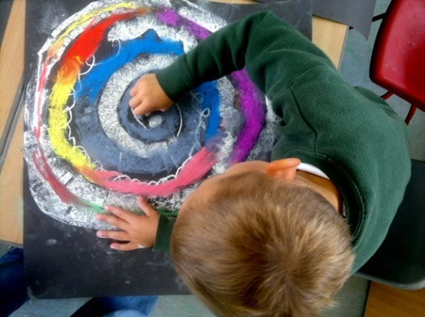  This pathway aims to introduce children to the idea that making a drawing is a physical activity which uses the whole body and connects head, hand and heart.  https://www.accessart.org.uk/spirals/ | 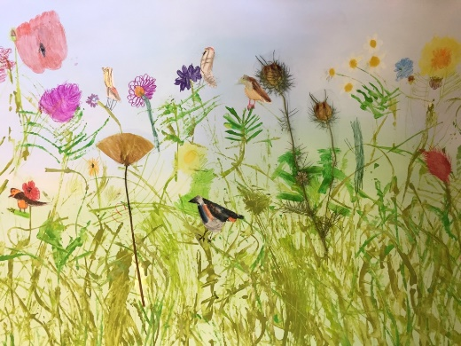  The aim of this pathway is to introduce children to the idea that artists can be inspired by the flora and fauna around them.  https://www.accessart.org.uk/flora-and-fauna/ | This pathway aims to help children begin to understand the relationship between drawing and making, 2d and 3d. Pupils explore how to transform materials into sculpture, moving from mark making to balance and structure.  https://www.accessart.org.uk/pathway-making-birds/  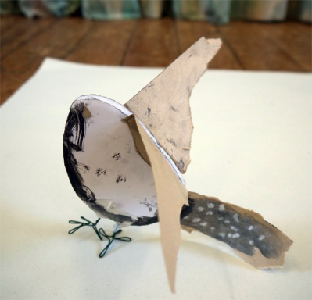
Can I Skills | I Can…  - I can draw from my finger tips, my wrist, my elbow, my shoulder, my body.  - I can make a drawing using a continuous line for a minute or two.  - I have made a sketchbook (or perhaps decorated the cover of a bought sketchbook) and I feel like it belongs to me.  - I can draw from observation for a few minutes at a time.  - I can make different marks with different drawing tools. I have seen the different marks I can make with a soft pencil, a graphite stick and a handwriting pen. | I Can…  - I have enjoyed looking at art made by other artists inspired by flora and fauna.  - I can look closely at insects and plants and make drawings using pen to describe what I see.  - I can experiment using graphite and oil pastel and make my own insects.  - I can cut out shapes in different colours, and use these shapes to make an insect or bug. I can think about its body parts and what I would like them to look like. | I Can…  - I can look carefully at photos and films of birds, take in the details and overall shapes, and then made drawings of what I have noticed.  - I can drawn from life looking closely.  - I can experiment with a variety of drawing materials and test ways to make marks that describe what I see.  - I can use colour in my drawings and mix two or more different media together.  - I have looked at the work of other artists who have been inspired by birds and I can share my response to their work.  - I can fold, tear, crumple and collage paper to transform it from 2d to 3d.  - I can use a variety of materials to make my own sculpture, and I have taken on the challenge of making my sculpture balance and stand.  - I have seen how my sculpture can be part of a class artwork. I can see how all our sculptures are individual.  - I can share my work with my classmates and teachers, and consider what was successful for me.

Year 2

Key Concepts | - Children learn that artists and architects observe the world with curiosity, collecting ideas and materials to inspire their work.  - They develop skills in observational drawing and begin to explore composition thoughtfully.  - They build confidence in experimenting with materials, taking creative risks, and embracing both planned outcomes and happy accidents.  - They are introduced to mono printing, using mark-making to create unique prints and imaginative narratives.  - They learn to generate ideas through drawing, using visual storytelling and invention.  - They explore architecture, understanding how buildings relate to people and environments.  - They use drawing, imagination, and making to design and build architectural models, sometimes inspired by real-world contexts or digital stimuli.  - Children begin to connect hand, eye, and imagination in more complex and purposeful ways, deepening their creative voice.
Generating Ideas | Children will enjoy looking at artwork by artists, craftspeople, architects, and designers, noticing elements that inspire them. They will explore a variety of source materials, including images on screens, in books, galleries, and museums, and engage with the physical world—seeing, holding, listening, and interacting with found and manmade objects—to spark creative responses. Children will ask questions about what they see, what they like and why, how it makes them feel, and what they would like to ask the artist. They will generate ideas through exploring materials, learning what each can do, experimenting with construction, and remaining open to unexpected possibilities.
 | Autumn  Drawing and Sketchbooks – Explore and Draw | Spring  Surface and Colour – Exploring the World Through Mono Print | Summer  Working in 3D – Be An Architect
Key Vocabulary | - Explore  - Collect  - ‘Re-See’  - Photograph  - Focus  - Light and shade  - Pattern  - Observational drawing  - Close study  - Wax resist  - Brusho  - Graphite  - Watercolour  - Mark making  - Line and shape | - Mono print  - Mono type  - Carbon paper  - Thinking, reacting and considering  - Pressure  - Line  - Impression  - Graphite  - Soft B pencil  - Chalk  - Soft pastel  - Oil pastel  - Life size  - Scale | - Architect  - Architecture  - Designer  - Model  - Scale  - Response  - Three dimensional  - Form  - Structure  - Balance  - Construction  - Composition  - Perspective
Focus | 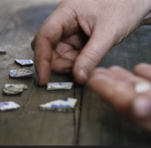  In this pathway children are introduced to the idea that artists can be collectors: they go out into the world, look at things in new ways, and bring things back to the studio to inspire their art.  Pathway: Explore & Draw | 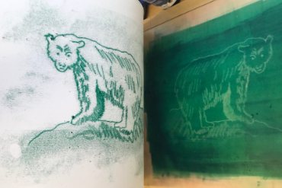  The aim of this pathway is to build on the exploration of drawing in Autumn term 1, this pathway starts with two explorations of drawing – one drawing from photographs or film, and two drawing from small, closely observed objects.  Pathway: Exploring the World Through Mono Print | 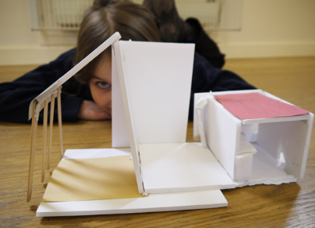This pathway gives pupils the opportunity to explore architecture. We start with an exploration of architects and some of the ways they work, and pupils then go on to create their own architectural model.  Pathway: Be An Architect
Can I Skills | I have seen how some artists explore the world around them to help them find inspiration.  I can explore my local environment (school, home, etc) and collect things which catch my eye.  I can explore composition by arranging the things that I have collected.  I can talk about what I collected, and how and why I arranged the things I collected.  I can use careful looking to practice observational drawing, and I can focus for 5 or 10 minutes.  I can combine different drawing media such as wax resist and watercolour, graphite and water, wax crayon and pencil in my observational drawings.  I can work small in my sketchbook and on large sheets of paper, exploring how I can use line, shape and colour in my work.  I can talk about the work I have made with my classmates, sharing the things I thought were successful and thinking about things I would like to try again. | I can make drawings using photos from films as my source material.  I can look closely guided by my teachers voice, and work in my sketchbook or on paper to make drawings using soft pencil or handwriting pen.  I can look closely at small objects close to me and make drawings with soft pencil or handwriting pen at the same scale or size.  I can think carefully about which marks I will include in my drawing.  I can share my sketchbook work with the class and talk about what I like about my work. I can listen to others talking about their work, and sometimes I can add my thoughts.  I have seen what a mono print is and have explored the work of an artist who uses mono print. I can share my thoughts on the artists work.  I can use carbon paper to make mono prints. I can experiment with the kinds of marks I make, and think about how they help make my drawings interesting.  I can base my drawings upon careful observational looking. I can slow down my looking and mark making and work for 5 to 15 minutes on a drawing.  I can explore a theme and make mono prints using my imagination to make my drawings personal.  I can share my work and talk about what I like, and what I would like to try again.  I can enjoy looking at the work of my classmates and sometimes I can share my thoughts about their work.  I have understood that through art, I can invent and discover. | I have explored the work of some architects. I have seen that they design buildings, and that “architecture” can be large, incredible buildings, or smaller places near where I live.  I can share how architecture makes me feel, what I like and what I think is interesting.  I can use my sketchbook to help me look at architecture really carefully. I have used drawings and notes. I have explored line and shape.  I have seen how architects use their imaginations to try to design buildings which make people’s lives better and I can use my own imagination when thinking about architecture I might design.  I can make an architectural model of a building around a theme thinking about form, structure and balance, and the way the model looks.  I can explore a variety of materials and explore how I can reshape the materials and fasten them together to make my model.  I have seen that I don’t need to design on paper first; that I can design as I make.  I have reflected upon what I have made, shared it with others, and been able to share my thoughts about my own piece and the models of my classmates.

Key Stage 2
Pupils should develop their technical skills, creativity, and confidence in using a wide range of materials and techniques. They should be encouraged to explore, experiment, and refine their control of processes while becoming increasingly aware of different forms of art, craft, and design. Learning should nurture curiosity, imagination, and personal expression while helping pupils make meaningful connections to artistic traditions and creative practices across time and culture. Pupils should investigate, explore, and develop their understanding and control of techniques while engaging with the work of artists, craftspeople, architects, and designers. They should encounter examples from both local contexts and a broad variety of national, cultural, and historical traditions.
Through creative, discursive, and practical activities, pupils should be taught:
- The knowledge, understanding, and skills needed to take part in a process of self-expression and personal response.
- Technical ability and confidence in core art and design processes, including drawing, painting, sculpture, and mixed-media work using materials such as pencil, charcoal, paint, and clay.
- How to create and use sketchbooks to record observations, review and refine ideas, and reflect on their creative journey.
Pupils should also learn to:
- Use a variety of materials creatively to design and make purposeful artwork.
- Apply drawing, painting, and sculpture to explore and communicate their ideas, experiences, and imagination.
- Develop a broad understanding of visual elements, exploring colour, pattern, texture, line, shape, form, and space.
- Study the work of great artists, architects, and designers, identifying similarities and differences between styles, methods, and intentions, and making connections to their own creative work.
To support this, teachers should:
- Introduce pupils to key works and features of selected artists, craftspeople, architects, and designers, encouraging comparison, discussion, and personal reflection.
- Use a range of resources — including images, films, books, reproductions, and where possible, visits to museums and galleries — to inspire curiosity, analysis, and imaginative response.
- Encourage pupils to articulate and share their ideas through discussion, using speaking and listening as tools to refine thinking and decision-making.
- Promote experimentation, risk-taking, and reflection as essential parts of the creative process.
Assessment in Key Stage 2 art and design should focus on how pupils develop and apply skills, express ideas with growing independence, and reflect on their creative choices. Assessment is ongoing, conversational, and built into the process of making and discussing art.
Teachers should look for evidence that pupils can:
- Use sketchbooks to record observations, develop ideas, and reflect on progress.
- Demonstrate control and confidence with a range of materials and techniques.
- Make thoughtful artistic choices about composition, colour, and form.
- Talk about their own and others’ work using appropriate artistic vocabulary.
- Show curiosity about different artists and make simple connections to their own work.
Progress should be recognised through creative dialogue and reflective questioning, such as:
- What have you learned from trying this technique?
- How did you decide which materials to use?
- How has your idea changed as you’ve worked?
- What do you like most about your work so far?
- What might you do differently next time?
- How does this artist’s work inspire or influence yours?

Year 3
Key Concepts | - Children explore drawing as a dynamic, physical activity, using expressive and gestural marks to create drama and mood.  - They experiment with charcoal and light, learning how material qualities can enhance storytelling and emotion in art.  - They discover how to combine painting and sewing, exploring how different materials (paint, fabric, thread) can be layered to build textured, expressive artworks.  - They use drawing and sketchbooks to respond personally to landscapes, developing ideas through mark making, colour, and composition.  - Children are introduced to animation, learning how to create movement through sequential drawings.  - They make simple paper puppets and backgrounds, using storytelling and imagination to bring their drawings to life.  - Across the year, they are encouraged to take creative risks, work across art and craft, and develop their own visual voice through experimental approaches.
Generating Ideas | Children will explore artwork by artists, craftspeople, architects, and designers, reflecting on the artist’s intentions and their own responses. They will make connections with other artforms, use a variety of materials, and engage with the world around them to spark ideas. Children will ask questions about what they see, like or dislike, how it makes them feel, and how it might inspire their own work. They will experiment with different media, develop ideas through playful making, and use digital tools to research creative practitioners.
 | Autumn  Drawing and Sketchbooks – Gestural drawing with charcoal | Spring  Surface and Colour – Thread, Cloth and Paint | Summer  Working in 3D – Making animated drawings
Key Vocabulary | - Charcoal  - Gestural  - Expressive  - Chiaroscuro  - Tone  - Positive and negative shapes  - Lighting  - Shadow  - Atmosphere  - Silhouette  - Mark  - Trace  - Composition  - Focus | - Mixed media  - Cloth  - Fabric  - Calico  - Acrylic paint  - Thread  - Stitches  - Needle  - Experiment  - Background  - Foreground  - Gesture  - Impasto  - Dilute  - Dot and dash | - Animate  - Animation  - Animator  - Character  - Movement  - Pose  - Gesture  - Intention  - Background  - Foreground  - Presentation  - Performance  - Film  - Focus
Focus | 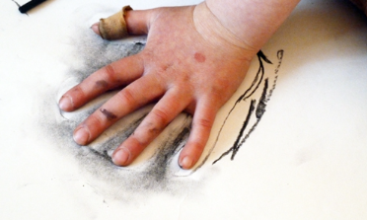  In this pathway, children discover how to make drawings that capture a sense of drama or performance using charcoal.  Pathway: Gestural Drawing with Charcoal | 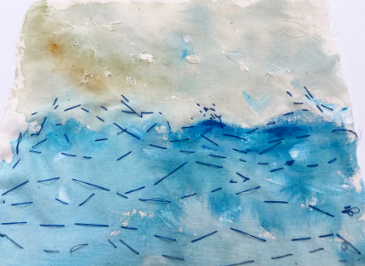  In this pathway children are introduced to artists that combine paint and sewing, art and craft, to make work. Children explore how these artists use fabric, paint and thread to make work in response to landscapes (and sometimes the people within those landscapes).  Pathway: Cloth, Thread, Paint | 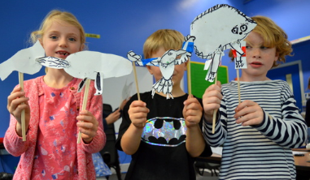  The aim of this pathway is to introduce children to the idea that we can create moving imagery through sequenced drawings.  Pathway: Making Animated Drawings
Can I Skills | I have seen how artists use charcoal in their work. I have been able to talk about the marks produced, and how I feel about their work.  I have experimented with the types of marks I can make with charcoal, using my hands as well as the charcoal.  I can work on larger sheets of paper, and I can make loose, gestural sketches using my body.  I can understand what Chiaroscuro is and how I can use it in my work.  I can use light and dark tonal values in my work, to create a sense of drama.  I have taken photographs of my work, thinking about focus, lighting, and composition.  I have shared my work with my classmates and talked about what I felt was successful and what I might like to try again. I can voice what I like about my classmates work and how it makes me feel. | I have explored how artists combine media and use them in unusual ways to make art.  I can share my response to their work.  I can use my sketchbook to make visual notes capturing ideas that interest me.  I can use my sketchbook to test ideas and explore colour and mark making.  I can use paint to create a background on fabric, mixing colours to create different hues, tints and dilutions.  I can use thread and stitching to create textural marks over the top of my painted canvas, creating interesting marks which reflect my response to the landscape.  I can share my work with others and share my thoughts about the process and outcome. I can listen to their feedback and take it onboard.  I can appreciate the work of my classmates enjoying the similarities and differences between our processes and outcomes. I can share my feedback on their work. | I can talk about the work of other animators who make animations from their drawings. I can share what I like, and how it makes me feel.  I can use my sketchbook to gather ideas from other artists, and start to think about a simple moving drawing I might make.  I can use observational skills to look at source material to inspire my character and make drawings.  I can use my imagination to think about how my character might move.  I can create a background for my character.  I can share my moving drawing, either through an animation or by showing classmates how it would move.  I can reflect and articulate my thoughts about my own artwork and that of my peers.

Year 4

Key Concepts | - Children learn to use drawing and sequencing to tell visual stories, incorporating text, line, shape, colour, and composition to add meaning and expression.  - They explore the illustrative and narrative power of drawing through projects like accordion books and comic strips, often in response to literature or poetry.  - They are introduced to still life as a historical and contemporary genre, using observational skills to explore objects with drawing, collage, painting, or sculpture.  - They experiment with media and composition to express personal meaning through still life, focusing on visual elements like texture, form, and space.  - Children consider presentation and context in sculpture, exploring how the way art is displayed affects its meaning.  - They investigate the concept of the plinth, creating individual or collaborative sculptural responses that explore identity, space, and audience interaction.  - Across the year, they deepen their creative decision-making, balancing personal expression with thoughtful presentation.
Generating Ideas | Children will explore artwork by artists, craftspeople, architects, and designers, reflecting on the artist’s intentions and their own responses. They will make connections with other artforms, use a variety of materials, and engage with the world around them—seeing, hearing, and handling objects—to inspire creativity. Children will ask questions about the artwork, including what they see, what they like or dislike, which senses it engages, what the artist is communicating, how it might inspire their own work, and where they would display it. They will take part in small-scale critiques to make brainstorming part of the creative process, experiment with different media, develop ideas through playful making, and use digital tools to research and learn from creative practitioners.
 | Autumn  Drawing and Sketchbooks – Storytelling through drawing | Spring  Surface and Colour – Exploring Still Life | Summer  Working in 3D – The Art of Display
Key Vocabulary | - Illustration  - Illustrator  - Inspiration  - Interpretation  - Graphic novel  - Poetry  - Prose  - Stage  - Arrange  - Composition  - Sequencing  - Visual literacy  - Narrative  - Quality of line  - Line weight  - Mark making  - Graphite | - Plinth  - Context  - Display  - Presentation  - Intention  - Viewpoint  - Art object  - Figurative  - Clay  - 3D sketches  - Position  - Re-imagine  - Exhibition  - Curating/curator | - Plinth  - Display  - Viewpoint  - Figurative  - Clay  - Empathy  - Position  - Character  - Re-see  - Re-imagine  - Environment  - Context  - Gallery  - Exhibition  - Scale  - Perspective  - Curating/curator
Focus | 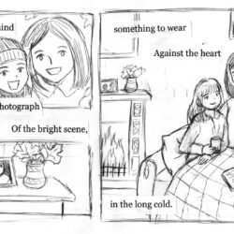  This pathway aims to enable pupils to think about how they can create sequenced drawings to share or tell a story.  https://www.accessart.org.uk/storytelling-through-drawing/ | 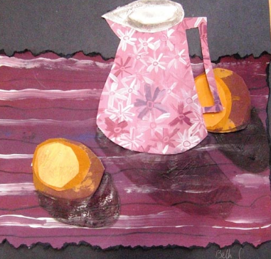  The aim of this pathway is to introduce children to the genre of still life, explore traditional and contemporary still life artists, and make their own creative response.  Pathway: Exploring Still Life | 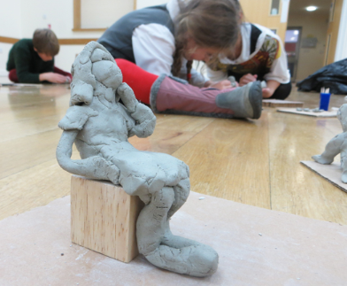  This pathway aims to encourage pupils to think about how the way we present our art (the context) can change the meaning of the work we make, or change the way others see it.  Pathway: The Art Of Display
Can I Skills | - I have explored the work of artists who tell stories through imagery.  - I can respond to the work of illustrators and/or graphic novelists, “reading” the visual images and sharing my thoughts.  - I can work in a sketchbook to record my ideas and thoughts generated by looking at other artists’ work.  - I can use a sketchbook to generate ideas about how I might respond to a piece of poetry or prose.  - I can use line, shape, and colour using a variety of materials to test my ideas.  - I can think about how I might use composition, sequencing, mark making and some text in my drawings.  - I can create a finished piece which contains sequenced images to describe a narrative.  - I can share my work with others and talk about my journey and outcome. I can listen to their feedback and take it on board.  - I can appreciate the work of my classmates and think about similarities and differences between our work. I can share my feedback on their work. | I have explored the work of contemporary and more traditional artists who work within the still life genre.  I have felt able to express my thoughts about other artists’ work, and talk about the meanings of objects as artists present them.  I can use my sketchbook to make visual notes, record and reflect.  I can draw from observation and think about how I can use line, colour, shape, texture, form and composition to make my artwork interesting.  I can present and share my artwork, and explain how my sketchbook work helped build my knowledge and skills towards my final piece. | I have seen how some artists choose to display their work on “plinths” and I have understood how the way a work is displayed can affect the way the audience sees the work.  I can use my sketchbook to collect ideas about how other artists consider how their work is displayed.  I can use clay to make quick three dimensional sketches of figures sitting on “plinths”. I can use the clay to capture character/emotion of the body.  I can share my work with others, and talk about my response to the project, what worked well and what I would like to try again. I can listen to the response to my work from my classmates and take on board their feedback.  I can appreciate the work of my classmates, understanding where there are similarities and where there are differences. I can share my response to their work.  I can take photographs of my artwork, thinking about focus, lighting and composition.  The following I Can statements are dependent upon project chosen.  Pocket Gallery:  I can find objects around me and think about how I can re-see them when I display them as art objects.  I can manipulate materials to make an environment for the art objects.  I can think about how the audience might react and capture this in my artwork.  The Fourth Plinth Challenge:  I can work as a small team and plan an art project around how we would use a plinth in our school, taking ideas of other people on board and contributing my own.  I can think creatively about art/object/performance/audience.  Plinth People  I can use my sketchbook to think about my interests/personality traits which I am proud of.  I can imagine how I could create a version of myself that I would like to see on a plinth.  I can make a sculpture/ plinth from construction materials which shows a version of myself, using things like body position, clothes, props and fine details to give the sculpture character.

Year 5

Key Concepts | - Children explore typography, learning how the design of letters and layout can communicate ideas and emotions.  - They create their own fonts and combine typography with visual elements, often in projects like storytelling maps.  - They investigate how design reflects culture, personal experience, and relationships between creator and viewer.  - They explore fashion design, understanding how 2D shapes transform into 3D forms and how clothes can express identity and emotion.  - Using sketchbooks, children develop and test ideas before making creative 2D or 3D fashion designs.  - They consider the social and environmental responsibilities of architects, discussing sustainable and aspirational building designs.  - They use form, materials, and scale to design and build architectural models that reflect thoughtful choices for individuals and communities.  - Throughout the year, children deepen their understanding of design as a powerful, expressive tool connected to real-world contexts.
Generating Ideas | Children will explore artwork by artists, craftspeople, architects, and designers, reflecting on the artist’s intentions and their own responses. They will make connections with other artforms, use a variety of materials, and engage with the world around them—seeing, hearing, and handling objects—to inspire creativity. Children will ask questions about the artwork, including what they see, what they like or dislike, which senses it engages, how it makes them feel, what the artist is communicating, how it might inspire their own work, and who or what else might feed their creativity. They will take part in small-scale critiques to make brainstorming part of the creative process, experiment with different media, develop ideas through playful making, and use digital tools, including camera phones, to research and record ideas in a digital sketchbook.
 | Autumn  Drawing and Sketchbooks – Typography and Maps | Spring  Surface and Colour – Fashion Design | Summer  Working in 3D – Architecture
Key Vocabulary | - Typography  - Lettering  - Graphics  - Design  - Communicate  - Purpose  - Intention  - Visual impact  - Exploratory  - Pictorial Maps  - Identity  - Symbols | - Contemporary  - Historical  - Fashion design  - Designers  - Design Brief  - Colour  - Texture  - Form  - Shape  - Material  - Body  - Wearable  - Fit for purpose  - Pattern cutting | - Domestic architecture  - Aspirational  - Visionary  - Environmental  - Tiny house  - Movement  - Form  - Structure  - Materials  - Balance  - Scale  - Interior  - Exterior  - Location  - Design through making  - Model  - Maquette
Focus | 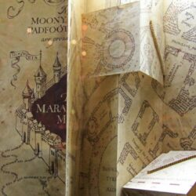  This pathway aims to give pupils the opportunity to explore the work of designers who work with font and typography. Pupils go on to create their own typography and develop their skills further in a visual map project.  https://www.accessart.org.uk/typography-and-maps/ | 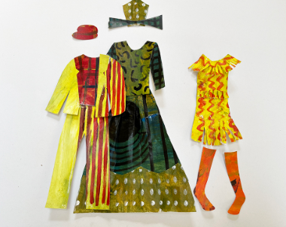  This pathway aims to present pupils with an opportunity to see how designers work to bring their own background, culture, passions and concerns into their fashion design. The pathway invites pupils to work to a design brief and express their response in two or three dimensions.  Pathway: Fashion Design | 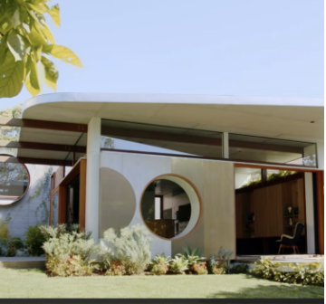  The aim of this pathway is to give pupils the opportunity to use their growing creative independence to discuss, decide, and design. Pupils will explore the responsibilities architects have to create a better world for us all by exploring whether we should “dream big or dream small” when it comes to planning for homes for the future.  Pathway: Architecture: Dream Big or Small?
Can I Skills | - I have understood that Typography is the visual art of creating and arranging letters and words on a page to to help communicate ideas or emotions.  - I have seen how other artists work with typography and have been able to share my thoughts on their work.  - I have explored how I can create my own letters in a playful way using cutting and collage. I can reflect upon what I like about the letters I have made.  - I have drawn my own letters using pen and pencil inspired by objects I have chosen around me. I can reflect upon why my letters have a meaning to me.  - I have used my sketchbooks for referencing, collecting and testing ideas, and reflecting. | I have explored the work of contemporary fashion designers and I can see how their interests and experiences feed into their work.  I can share my own response to their work, articulating what I like or don’t like about their work.  I can use my sketchbook to make visual notes to capture key ideas about how the designers work.  I can listen to a design brief, and use my sketchbook to generate and test ideas, explore colour, line, shape, pattern in response to the brief.  I can use my sketchbook work to inform how I make a 2d (or 3d) design, using paint, paper and collage.  I can understand how 2d shapes can become 3d form and the relationship they have to our bodies.  I can share my designs and outcomes with my classmates and articulate my journey. I can listen to their feedback and respond.  I can appreciate the work of my classmates and reflect upon similarities and differences. I can share my response to their work. | I have explored domestic architecture which is aspirational and large, and I have explored the Tiny House movement. I can discuss with the class how both these ways of designing might affect our lives.  I can use my sketchbook to collect, record and reflect my ideas and thoughts.  I can make larger drawings working from still imagery, using various drawing techniques for fifteen or so minutes.  I can explore how line, form, structure, material, and scale are all used to make architecture interesting, and help the designer meet the design brief.  I can make an architectural model using the ‘design through making’ technique, using my sketchbook to help free my imagination.  I can present my work, reflect and share it with my classmates.  I can respond to the work of my classmates, sharing my thoughts about their work in relation to the architecture we looked at during the project.  I can photograph my work considering lighting, focus and composition.

Year 6

Key Concepts | - Children deepen their understanding of the close relationship between drawing and making, transforming 2D surfaces into 3D objects.  - They use drawing techniques like the grid method and observing negative space to develop accurate and inventive artworks.  - They explore how elements such as line, mark making, value, colour, pattern, and composition contribute to both drawing and sculptural work.  - Pupils choose between projects focused on sculpture or graphic design/packaging, applying their drawing skills in different creative contexts.  - They learn about art as activism, using art to express opinions and communicate powerful messages through printmaking, collage, and drawing.  - Children explore how colour and form can create immersive, emotional environments, experimenting with brave colour combinations and 2D/3D models.  - They develop ideas through sketchbooks, testing and reflecting on their creative vision.  - Throughout the year, pupils build confidence in using art to share personal passions, communicate with others, and solve creative challenges.
Generating Ideas | Children will explore artwork by artists, craftspeople, architects, and designers, reflecting on the artist’s intentions and their own responses. They will make connections with other artforms, use a variety of materials, and engage with the world around them—seeing, hearing, and handling objects—to inspire creativity. Children will ask questions about what they see, what they like or dislike, which senses it engages, how it makes them feel, what the artist is communicating, how it might inspire their own work, and who or what else might feed their creativity. They will take part in small-scale critiques to make brainstorming part of the creative process, experiment with different media, develop ideas through playful making, and use digital tools, including camera phones, to research and record ideas in a digital sketchbook.
 | Autumn  Drawing and Sketchbooks- 2d Drawing to 3D Making | Spring  Surface and Colour – Brave Colour | Summer  Working in 3D – Activism
Key Vocabulary | - 2D drawing  - 3D object  - Packaging  - Negative space  - Grid method  - Scaling up  - Net  - Typography  - Graphic Design  - Collage  - Structure  - Balance | - Visual notes  - Installation Art  - Immersive  - Context  - Environment  - Viewer  - Light  - Colour  - Form  - Structure  - Sound  - Senses  - Sculptural installation | - Activism  - Voice  - Articulate  - Message  - Community  - Poster  - Zine  - Screen-printing
Focus | 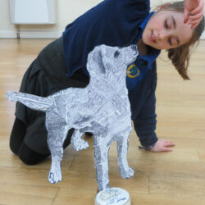  This pathway enables pupils to consider how 2 dimensional drawing might relate / transform to 3 dimensional making.  https://www.accessart.org.uk/2d-drawing-to-3d-making/ | 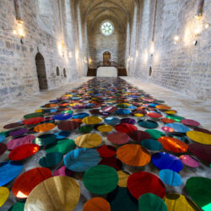  This pathway gives pupils the opportunity to engage with colour in an intuitive and physical way.  Pupils are given a greater degree of creative independence and the pathway invites pupils to respond to the following questions:  “How can we create colourful experiences? How do they make us feel? How might we connect to others through colour?”  Pupils are encouraged to guide their own exploration, making choices about how they want to use colour in their artwork.  https://www.accessart.org.uk/brave-colour/ | 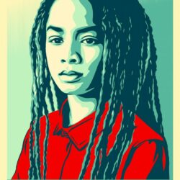  This pathway introduces pupils to the idea that artists can use their skills, vision and creativity to speak on behalf of communities, changing the world for the better.  https://www.accessart.org.uk/activism/
Can I Skills | - I have explored artists who use their drawing skills to make objects, and I can share my responses to their work, thinking about their intention and outcome.  - I can use my sketchbook to record and reflect, collecting the ideas and approaches I like which I see other artists use.  - I can use line, mark making, tonal values, colour, shape and composition to make my work interesting.  - I can use negative space and the grid method to help me see and draw.  - I can explore typography and design lettering which is fit for purpose.  - I can transform my drawing into a three dimensional object.  - I can share my work with others, and talk about my intention and the outcome. I can listen to their response and take their feedback on board.  - I can appreciate the work of my classmates. I can listen to their intentions and share my response to their work.  - I can photograph my three dimensional work, thinking about presentation, lighting, focus and composition. | I have explored the work of installation artists who use colour, light and form to create immersive environments. I have been able to imagine what it might be like to be in those environments, and to share my thoughts with others.  I can respond to a creative challenge or stimulus, research the area, and make a creative response.  I can create a 3d model or 2d artwork which shares my vision with others.  I can use a sketchbook to focus my exploration of colour, taking time to record thoughts, test ideas and reflect.  I can present my ideas and vision to others, articulate my thoughts and listen to the response of my classmates, taking on board their feedback.  I can listen to the creative ideas of others, and share my feedback about their work. | I have seen how artists use their skills to make art which speaks about things which matter, often on behalf of whole communities.  - I have explored how I can find out what I care about, and find ways I might share my ideas with us.  - I have seen how my classmates may have different things they care about, or share things we care about, but they are all valid.  - I can create visuals and text which communicate my message.  - I can use line, shape and colour to make my artwork.  - I can use typography to make my messages stand out.  - I can combine different techniques such as print, collage and drawing.  - I can reflect and articulate about my own artwork and artwork made by my classmates.

