

**BOWERHAM PRIMARY & NURSERY SCHOOL**

**&**

**BABY UNIT**

**EYFS Visits and Outings**

**DATE: July 2025**

**Review date: July 2026**

**Stand tall, reach high, love learning**

*The Bowerham School community is proud to nurture aspiration, inspire love for life-long learning and prepare children for a changing society.*

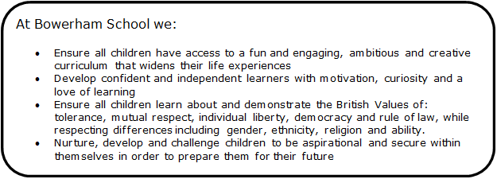

Within our Bowerham Baby Unit we follow all Bowerham Primary & Nursery School’s policies and procedures. Any wording highlighted in blue within the policies are specific additions only applicable to our Baby Unit.

At Bowerham Primary and Nursery School and Baby Unit we offer children a range of local outings including walks and visits off the premises. We believe that planned outings and visits complement and enhance the learning opportunities inside the nursery environment and extend children’s experiences. We always seek parents’ permission for children to be included in such outings.

**Procedures**

Visits and outings are carefully planned using the following guidelines, whatever the length or destination of the visit:

• A pre-visit checklist and a full risk assessment is completed on EVOLVE to assess the risks or hazards which may arise for the children, and identify steps to be taken to remove, minimise and manage those risks and hazards. We will endeavour to visit the venue prior to the visit. This will ensure that the chosen venue is appropriate for the age, stage and development of the children

• Written permission will always be obtained from parents before taking children on trips

• We provide appropriate staffing levels for outings dependent on an assessment of the safety and the individual needs of the children.

• At least one member of staff will hold a valid and current paediatric first aid certificate and this will be increased where risk assessment of proposed activity deems it necessary

• A fully stocked first aid box will always be taken on all outings along with any special medication or equipment required

• A completed trip register together with all parent and staff contact numbers will be taken on all outings

• Regular headcounts will be carried out throughout the outing.

• All staff and children will be easily recognisable by other members of the group; they will wear their uniform and high visibility vests/jackets

• All staff members will carry a mobile phone as a means of an emergency

• In the event of an accident, staff will assess the situation. If required, the group will return to school/nursery immediately and parents will be contacted to collect their child. In the event of a serious accident an ambulance will be called at the scene, as well as parents being contacted. One member of staff will accompany the child to the hospital, and the rest of the group will return to the school/nursery.

**Risk assessment/outings plan**

A letter will be sent to parents detailing information about the trip.

This letter will include details of:

• The name of the place where the visit will take place

• The estimated time of departure and arrival

• Method of transportation and travel arrangements (including the route)

• Financial arrangements

• Emergency procedures

• All staff members shall inform parents in advance of any visits or outings involving the transportation of children away from the school/nursery

• The arrangements for transporting children will always be carefully planned and where necessary additional people will be recruited to ensure the safety of the children. This is particularly important where children with disabilities are concerned

• All staff vehicles used in transporting children are properly licensed, risk assessed and insured.

• All vehicles used are fitted to the supplier’s instructions with sufficient numbers of safety restraints appropriate to the age/weight of the children carried in the vehicle. Any mini buses/coaches are fitted with 3-point seat belts

• When children are being transported, we maintain ratios. When planning a trip or outing using vehicles, records of vehicles and drivers including licenses, MOT certificates and business use insurance are checked. If a vehicle is used for outings the following procedures will be followed:

• Ensure seat belts, child seats and booster seats are used

• Ensure the maximum seating is not exceeded

• All children will be accompanied by a registered member of staff

• No child will be left in a vehicle unattended

• Extra care will be taken when getting into or out of a vehicle

**Lost children**

In the event of a child being lost, the Missing Child Procedure will be followed. Any incidents or accidents will be recorded in writing and Ofsted will be contacted and informed of any incidents.