

 **BOWERHAM PRIMARY & NURSERY SCHOOL**

**AND BABY UNIT**

**EYFS Sleep Policy**

**DATE: July 2025**

**Review date: July 2026**

**Stand tall, reach high, love learning**

*The Bowerham School community is proud to nurture aspiration, inspire love for life-long learning and prepare children for a changing society.*

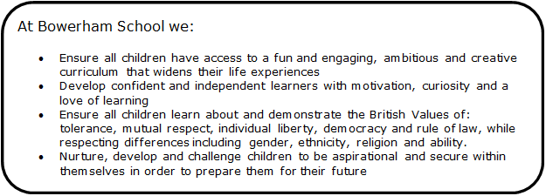

At Bowerham Primary and Nursery School and Baby Unit we aim to ensure that all children have enough sleep to support their development and natural sleeping rhythms in a safe environment.

**The safety of babies’ and young children sleeping is paramount.**

**Our policy follows the advice provided by The Cot Death Society and Lullaby Trust to minimise the risk of Sudden Infant Death. This is in line with the latest government safety guidance:** [**https://www.nhs.uk/conditions/sudden-infant-death-syndrome-sids/**](https://www.nhs.uk/conditions/sudden-infant-death-syndrome-sids/)**. We also follow the NHS advice on safety of sleeping children.** [**https://www.nhs.uk/conditions/baby/caring-for-a-newborn/reduce-the-risk-of-sudden-infant-death-syndrome/**](https://www.nhs.uk/conditions/baby/caring-for-a-newborn/reduce-the-risk-of-sudden-infant-death-syndrome/)

**We make sure that:**

• Babies are placed on their backs to sleep, if a baby has rolled onto their tummy, you should turn them onto their back again, however once a baby can roll from back to front and back again, on their own, they can be left to find their own position

• Babies/toddlers are never put down to sleep with a bottle to self-feed

• Babies/toddlers are monitored visually when sleeping. Checks are recorded every 10 minutes and babies are never left in a separate sleep room without staff supervision at all times. To ensure that staff carry out safety checks appropriately and at the correct times, staff will set timers on individual i-pads.

• When monitoring, the staff member looks for the rise and fall of the chest and if the sleep position has changed

• As good practice we monitor babies under six months or a new baby sleeping during the first few weeks every five minutes until we are familiar with the child and their sleeping routines, to offer reassurance to them and families.

**We provide a safe sleeping environment by:**

• Monitoring the room temperature – this should be between 16-20 degrees

• Using clean, light bedding/blankets and ensuring babies/children are appropriately dressed for sleep to avoid overheating

• Only using safety-approved cots or other suitable sleeping equipment (i.e. pods or mats) that are compliant with British Standard regulations, and mattress covers are used in conjunction with a clean fitted sheet

• Not using cot bumpers or cluttering cots with soft toys, although comforters will be given where required

• Keeping all spaces around cots and beds clear from hanging objects i.e. hanging cords, blind cords, drawstring bags

• Ensuring every baby/toddler is provided with clean bedding

• Transferring any baby/child who falls asleep while being nursed by a practitioner to a safe sleeping surface to complete their rest

• Having a no smoking policy.

We ask parents to complete sheets on their child’s sleeping routine with the child’s key person when the child starts at nursery and these are reviewed and updated at timely intervals. If a baby has an unusual sleeping routine or a position that we do not use in the nursery i.e. babies sleeping on their tummies, we will explain our policy to the parents and not usually offer this unless the baby’s doctor has advised the parent of a medical reason to do so in which case we would ask them to sign to say they have requested we adopt a different position or pattern on the sleeping babies form. See appendix 1.

We recognise parents’ knowledge of their child with regard to sleep routines and will, where possible, work together to ensure each child’s individual sleep routines and well-being continues to be met. However, staff will not force a child to sleep or keep them awake against his or her will. They will also not usually wake children from their sleep. Staff will discuss any changes in sleep routines at the end of the day and share observations and information about children’s behaviour when they do not receive enough sleep.

**Sleeping twins**

We follow the advice from The Lullaby Trust regarding sleeping twins. Further information can be found at:

www.lullabytrust.org.uk