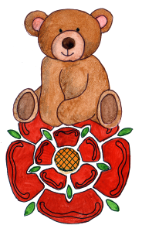

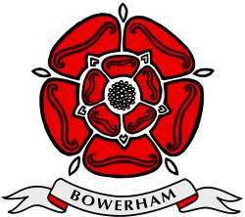 **BOWERHAM PRIMARY & NURSERY SCHOOL**

**&**

**BOWERHAM BABY UNIT**

**EYFS Hygiene Policy and Procedures**

**DATE: July 2025**

**Review date: July 2026**

**Stand tall, reach high, love learning**

*The Bowerham School community is proud to nurture aspiration, inspire love for life-long learning and prepare children for a changing society.*

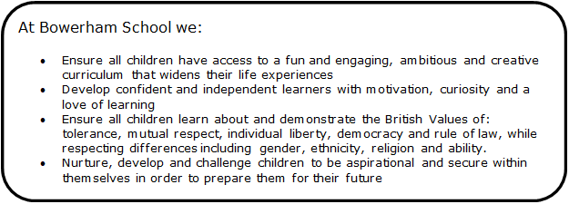

Within our Bowerham Baby Unit we follow the policies and procedures as outlined for Bowerham Primary and Nursery School. Statements highlighted in blue are additional policy statements specific to our Baby Unit.

Bowerham School is committed to providing and promoting a clean and hygienic environment to safeguard the physical and emotional well-being of all children. This means ensuring that all staff, parents, carers and volunteers are aware of and follow hygiene procedures, and that children are shown the importance of good hygiene practices.

# Personal Hygiene

In all circumstances, we will adhere to the following examples of good personal hygiene:

* Washing hands before and after handling food or drink.
* Washing hands after using the toilet.
* We will use paper towels/hand dryers and children will be helped to wash their hands to ensure that they are washed and dried correctly.
* All cuts and abrasions will be covered.
* We will encourage children to be independent when wiping their noses but will help as necessary. Tissues will be supplied.
* Additional hygiene measures continue to be implemented alongside daily and termly risk assessments when necessary.Please see the table below.

|  |
| --- |
| Have all door handles, handrails, table tops, electronic devices (such as i-pads) and surfaces been wiped down after each session?  Is there enough hand sanitizer available for use?  Have all malleable resources, including sand, been replenished/replaced?  Have all resources / play equipment from provision areas been cleaned appropriately ready for use after each session?  Have toilets been cleaned after each session has finished?  Have children been encouraged to regularly wash their hands thoroughly throughout the session, particularly after using the toilet, before eating and after sneezing/coughing or putting their hands in their mouths? |

# Hygiene in play areas.

# Blue & white cloths will be used to clean craft areas and all other areas within the classroom (except the snack, food preparation areas and toilet areas).

* Children in all early year’s classes, but specifically in our baby room and nursery will be encouraged not to place toys and equipment into their mouths. If this does occur, the staff member will remove the toy/piece of equipment immediately and will then clean/sterilise according to its cleaning guidelines.
* Bowerham Primary and Nursery and Baby Unit aims to promote children’s well-being and safety at all times. For non-mobile children and small toddlers it is essential that they have the opportunity to explore their environment safely. To help us do this we have guidelines that will; prevent contaminated items from being walked into rooms and on to floors where children lay, crawl or play. Prevent injury to the children from visitors or staff treading on fingers or toes.
* Staff will wear ‘crocs’ whilst indoors and will change from/ into appropriate outdoor footwear on entering or leaving the building.

· Parent’s delivering or collecting children are asked to put shoe covers on outdoor shoes before entering the room to collect their child/ or remove their outdoor shoes.

· Remove children’s outdoor shoes and place in the pocket above the coat pegs before entering the room.

· All children will wear socks when indoors.

# Dealing with spillages

* Spillages of substances likely to result in the spread of infections will be dealt with rapidly and carefully.
* Blood, vomit, urine and faeces will be cleaned up immediately using ‘sanitaire’. This will then be disposed of safely and hygienically using paper towels or the mop provided for this purpose – all mops and cleaning equipment are kept in locked areas within the classroom. In Nursery and Reception Class cleaning equipment is kept in a locked cupboard.
* Staff will wear disposable plastic gloves and an apron at all times when dealing with spillages.
* Children will be kept well clear while such substances are being dealt with.

# Toileting hygiene

* Red cloths will be used for all toilet, wash room and changing areas.
* Red handled mops will be used only in toilet, washroom and changing areas.
* Staff will wear disposable gloves and aprons when dealing with toileting care. Please see our toileting and care procedures for additional information.
* Toilet areas will be checked and cleaned at the end of each session by named staff using appropriate disinfectants. Nappy changing facilities will be cleaned by named staff after each use following the nappy changing procedures.
* Signs are in place to encourage adults and children to wash their hands after using the facilities
* All clinical waste – e.g. disposable nappies, wipes – will be disposed of in appropriate labelled bins and removed in a properly managed way (see also our Health and Safety policy).
* Potties are suitably cleaned with disinfectant after each use and appropriately stored following the potty procedure.

# First Aid and hygiene

In accordance with the Statutory Framework for the Early Years Foundation Stage 2021 at least one person is always available and is on the premises who is paediatric first aid (PFA) trained. A full list of all PFA trained staff is available on display next to all first aid boxes. At Bowerham we aim to ensure that all our EYFS staff are paediatric first aid trained. PFA training is renewed for all EYFS staff every three years. The first aid box will be checked half termly and replenished as necessary. All staff will wear gloves and aprons when dealing with cuts and grazes (blood). Ice packs will be kept in the fridges for use on bumps etc.

**Kitchen and snack preparation hygiene**

All areas where food and bottles are stored, prepared and used for eating/drinking are prone to the spread of infections. Therefore, we must be particularly careful to observe high standards of hygiene at all times: Green cloths will be used for all food preparation areas.

* All adults preparing food, drinks or bottles will wash their hands prior.
* Waste will be disposed of safely and all bins will be kept covered.
* Food storage facilities will be thoroughly cleaned on a daily basis.
* Fridges and microwaves will be cleaned on a weekly basis or more often if required.
* Separate cloths will be used for the preparation/cleaning of food areas (green cloths)
* Kitchen equipment will be thoroughly cleaned after every use.
* Staff and children will wash and dry their hands thoroughly before coming into contact with food.
* All fruit and veg to be washed before serving.
* Bottles or milk are not to be reheated due to bacterial growth.
* If cooking is done as an activity, all surfaces and equipment involved will be thoroughly cleaned before and after the session, using antibacterial cleaners. Adults and children will also wear aprons.
* Tables used for serving meals and snacks will be cleaned with an anti bacterial cleaner prior to use.
* Spillages will be cleaned up immediately.

The kitchen and snack preparation areas will be checked daily and any problems brought to the attention of the class teacher.

**Sterilising**

All feeding utensils (bottles, drinking cups, spoons) must be sterilised for all children under the age of one year. Staff must consult with parents when the child turns one to ensure they are happy for the nursery to stop sterilising. A child may have a health condition/ or other reason why sterilising must continue.

* All bottles/feeding equipment/dummies should be appropriately stored. These should also be sterilised before use (following sterilising procedures), and thoroughly cleaned and sterilised if dropped on the floor.

**Bedding**

* Each child within the Baby Unit will be provided with their own set of bedding (fitted sheet). This will be kept in a named drawstring bag and will be washed with non-biological wash powder at the end of the week by the Nursery team.
* Parents and carers will provide a lightweight blanket of preference and comforters as appropriate i.e. dummies. These items will be returned on a daily/weekly basis for parents to clean as they wish.
* Parents who wish for their child to have their child’s fitted sheet washed with an alternative wash powder due to an allergy or skin sensitivity can take their child’s fitted sheet home to be washed on a weekly basis.

**Animals**

* No animal will be allowed on the premises without the prior knowledge and the risks considered – A member of staff will complete a specific risk assessment which will be agreed by the Headteacher. The person responsible for the risk assessment will then inform all other adults of the risks and how best to manage them.
* Parents will be informed of the specific activity that is taking place.
* All children and adults will wash hands with antibacterial soap after handling animals.