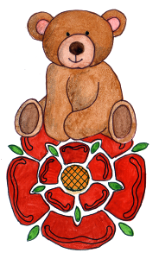

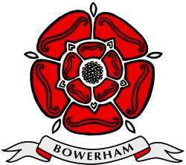**BOWERHAM PRIMARY & NURSERY SCHOOL**

**&**

**BABY UNIT**

**Baby Unit Infant Formula and Feeding Policy and Procedures**

**DATE: July 2025**

**Review date: July 2026**

**Stand tall, reach high, love learning**

*The Bowerham School community is proud to nurture aspiration, inspire love for life-long learning and prepare children for a changing society.*

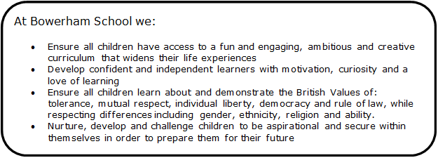

At Bowerham Primary and Nursery School children’s individual needs will be discussed with parents to ensure that they are met.

Feeds will be prepared as and when they are required by the babies and not as part of the baby unit routine.

**Breast Milk Policy**

Bowerham Primary and Nursery School and Baby Unit participates in the active encouragement of mothers to breast feed their babies. Therefore, we have put into place a policy and associated procedures to detail those arrangements necessary for the safe storage and use of breast milk. We also welcome mothers to breastfeed within the baby unit if they wish to do so. This will be discussed with the mother on induction.

**Containers**

· Breast milk should be brought to the Baby Unit in a sterilized bottle suitable for the purpose of refrigerated storage and clearly marked with the infant’s full name and dated.

· Bottles will be returned to parents/carers at the end of each day. The containers will be washed but not sterilized.

· Parents must ensure that the container is sterilized before re-use.

**Storage**

Breast milk should be provided on a daily basis, unused milk will be discarded at the end of each feed.

**General Handling**

**Carers will ensure that the following policy is strictly adhered to;**

· Breast milk is to be kept sterile at all times

· DO NOT leave breast milk at room temperature for more than 1 hour

· DO NOT heat breast milk on the stove or in the microwave

**Nursery Breast Milk Procedures**

**The following procedures are to be used by all staff handling, storing or using breast milk to feed an infant. See appendix 1:**

**On Delivery:**

· Ensure that the parent has provided the breast milk in an airtight sterilised bottle clearly marked with the child’s name and dated

· Breast milk is to be placed at the back of the fridge where it is the coolest prior to feeding an Infant with breast milk

· Before feeding an infant with breast milk, ensure that:

· A positive identification of the child is made, the date is checked and the correct breast milk is fed to the correct child

· Staff to ensure that they put on gloves and an apron when feeding a child breast milk

**Warming Breast Milk**

· Breast milk is to be warmed to a suitable body temperature to take the ‘edge’ off the milk by placing it in a bottle warmer

· The milk is then to be checked for temperature to ensure that the milk is cool enough for the baby to drink, using a temperature probe.

* The temperature probe will be sterilised after each use.

· DO NOT HEAT breast milk on the stove or in the microwave.

**Feeding an Infant with Breast Milk**

· Feed the baby as normal using a suitable bottle and teat

· Ensure that the baby is ‘winded’ correctly.

**After feeding an infant with Breast Milk**

· Unused breast milk (in that bottle) is to be discarded after 1 hour

· Record feed time and amount taken by the infant using the care diary on tapestry

· Discard gloves and apron

· After final feed or at the end of the day discard all thawed and unused breast milk stored for that child

**Hygiene**

Breast milk is a bodily fluid, which carries with it a (small) risk of infection and/or disease. The policy is to advise staff handling or carrying out the feeding of breast milk to protect themselves against the risks of infection by;

· Implementing good hygiene practices

· Using the PPE provided (advisable but not mandatory)

· Avoiding actual contact with the breast milk

· Only employees that hold a level 2 food hygiene, or have undertaken training by management will undertake feed preparation duties

**Formula Milk Policy**

**Those parents whom have requested their child to have formula milk at nursery must either;**

* Provide either: a carton of ready to use formula milk, a sealed pre- prepared formula powder as originally purchased or pre pared- formula powder in a sealed airtight container (with suitable pre- measured compartments which is named) alongside a suitable named bottle.
* In the above circumstances the Baby Room leader must ensure that if a parent provides a bottle and separate formula powder the parent must state in writing the amount of boiled water that is to be used to make the formula milk i.e.
* If a baby is provided with enough powder for 6 oz of milk then the written permission must state 6 oz of water.
* This written permission should be included on a sticker and placed onto the airtight containing the milk formula. See appendix 3.
* Provide suitable ready-made formula milk in cartons, which can be opened and then discarded at the end of the day.
* The formula milk carton is to be warmed as advised on the carton itself.
* **All items MUST be clearly named and dated.**

**Formula Milk Procedures**

**The following procedures are to be used by all staff, handling, storing or using formula milk to feed a baby. See appendix 2**:

**On Delivery:** Ensure that the parent has provided the powder in an airtight container /or a carton of formula milk and a pre-sterilised bottle clearly marked with the babies name and date prior to feeding a baby with formula milk

**Before feeding a child with formula milk, ensure that**;

A positive identification of the baby is made, and the correct formula milk is fed to the correct baby

**Preparing Formula Milk**

**To prepare a babies formula milk staff must;**

· Put on disposable apron (advisable but not mandatory)

· Read thoroughly the parents instructions to indicate the amount of water that is to be boiled

· Clean and disinfect the surface that will be used to prepare the feed

· Wash hands

· Measure the correct quantity of boiled water into the bottle

· Allow the water to cool for at least 20 minutes so that a reaches a temperature of approximately 70 degrees

· Mix into the water the correct measurement of formula powder from the premeasured powder container

· Attach the sterilised teat and shake the bottle vigorously until the powder is dissolved.

· The milk is then to be tested using a temperature probe so that it is at body temperature.

· If the milk is still too warm to feed the baby with, hold the bottle under cool running water until it cools. Repeat the above step.

**Feeding a baby with Formula Milk**

· Feed the baby as normal using their bottle and teat

· Ensure that the baby is ‘winded’ correctly – following the advised ‘winding’ technique. See appendix 4.

**After feeding a baby with Formula Milk**

· Discard any milk that has not been used within 1 hour

· Record feed time and amount taken by the baby on the care diary on Tapestry

**Staff Responsibilities**

· Staff will follow the correct procedures for handling either formula or breast milk and will adhere to both food hygiene standards and health and safety guidelines.

· Staff will adhere to this policy and its procedures.

· Staff will ensure that the ‘Daily Formula and breast Milk Preparation Sheet’ is filled in accordingly. These will be kept on a half termly basis and will be shredded at the beginning of each half term. See appendix 5.

· Staff should record the amount of formula or breast milk consumed by the baby on the baby’s care diary on Tapestry so that the parent can be informed of the child’s intake for that day.

· During a feed: Babies will never be left unsupervised. A member of staff (if possible their key person) should hold the baby and sit on the armchair in the baby room.

· Staff are not required to wear gloves or aprons when feeding bottles to babies as it is important to make them feel comfortable and to feed them in a ‘home like’ environment.