**Bowerham Pupil Premium Strategy Statement 2025-26**

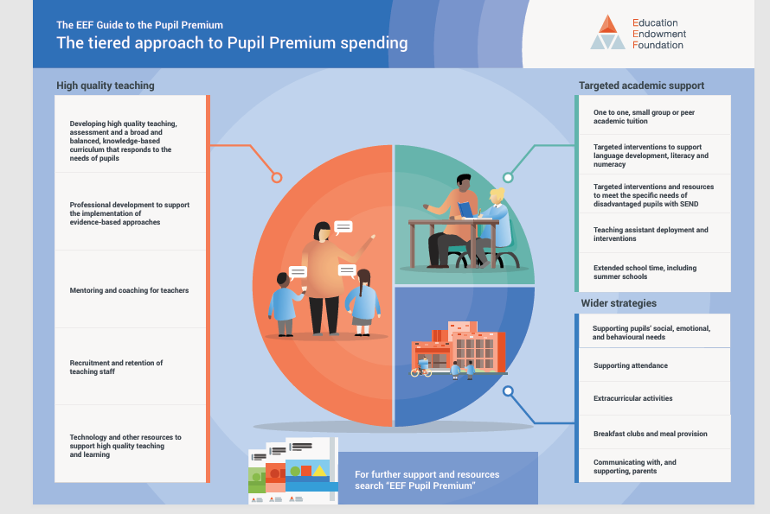To effectively narrow the attainment gap for children in receipt of Pupil Premium funding, here are key strategies aligned with your school’s priorities and practices:

**Our Vision:** To effectively narrow the gap in attainment for children in receipt of Pupil Premium funding, ensuring their progress and achievement are in line with their non-Pupil Premium peers.

**Our Aims:** We aim to support all eligible pupils by:

* Ensuring high-quality teaching across the school that meets the needs of disadvantaged pupils.
* Implementing targeted interventions designed to accelerate progress and address gaps in learning.
* Providing enrichment opportunities that broaden pupils' experiences and support their social, emotional, and academic development.
* Delivering comprehensive pastoral care to ensure pupils feel safe, supported, and ready to learn.

**Key Strategies for Improvement:**

**High-Quality Teaching:**

* + Prioritise professional development for staff to enhance teaching strategies that support disadvantaged pupils.
  + Embed metacognitive approaches to develop pupils' thinking and reasoning skills.
  + Ensure clear curriculum planning identifies essential knowledge and builds on prior learning to secure progress.

**Targeted Academic Support:**

* + Implement evidence-based interventions tailored to individual pupil needs.
  + Use assessment data rigorously to identify gaps and track progress.
  + Provide additional tutoring and small-group interventions for pupils who require further support.

**Enrichment and Pastoral Support:**

* + Offer a range of enrichment activities, including sports, arts, and outdoor learning, to boost confidence and engagement.
  + Develop the school's indoor and outdoor SEN provision to enhance social skills and support children in achieving their EHCP and ILP targets.
  + Maintain robust safeguarding practices and provide pastoral support to address emotional and well-being needs.

**Monitoring and Evaluation:**

* Conduct regular assessment reviews to track progress and adapt interventions as needed.
* Use pupil voice to assess the impact of strategies on learning and well-being.
* Maintain close communication with parents and carers to ensure collaborative support.

**Success Criteria:**

* Improved attainment and progress outcomes for Pupil Premium pupils, closing the gap with non-Pupil Premium peers.
* Increased engagement in learning and school life.
* Enhanced emotional well-being and resilience, enabling pupils to thrive academically and socially.

By adopting this comprehensive approach, Bowerham Primary and Nursery School and Baby Unit are committed to ensuring that every child, regardless of background, receives the support they need to achieve their full potential.

|  |  |  |  |  |  |
| --- | --- | --- | --- | --- | --- |
| 1. **Summary Information** | | | | | |
| **School** | Bowerham Primary and Nursery school & Baby Unit | | | | |
| **Financial Year** | **2025-26** | **Total PP budget** | £121, 070  Down £28,450 from last years allocation | **Date of most recent PP Review** | April 25 |
| **Total number of pupils** | 503  87 of which are nursery | **Number of pupils eligible for PP** | PP – 102 chn  20%  FSM – 85 chn 17%  LAC- 16 ch- 3%  Service- 6 chn 1% | **Date for next Strategy Review** | Oct 25  Feb 26  June 26 |

|  |
| --- |
| 1. **Current Attainment** |

|  |  |  |  |  |  |  |  |  |  |  |
| --- | --- | --- | --- | --- | --- | --- | --- | --- | --- | --- |
| 23/24 | Reading | | Writing | | GPS | | Mathematics | | Combined RWM | |
| NOR 60 | %  EXS+ | %  GDS | %  EXS+ | %  GDS | %  EXS+ | %  GDS | %  EXS+ | %  GDS | %  EXS+ | %  GDS |
| School TA 24 | 78% | 38% | 82% | 17% |  |  | 80% | 30% | 72% | 12% |
| School Test results | 73% | 20% | 82% | 17% | 78% | 27% | 58% | 30% | 55% |  |
| National headlines3 for 202 | 73% | 29% | 71% | 13% | 72% |  | 73% |  | 59% |  |
| FSM | 60% | 10% | 80% | 10% | 70% | 30% | 30% | 10% | 30% | 10% |
| Average Scaled Score  School | 103 | | N/A | | 105 | | 102 | |  | |
| Average Scaled Score  National 23 | 105 | | N/A | | 105 | | 104 | |

|  |
| --- |
| 1. **Barriers to learning from analysis of needs carried out by the families team** |
| In school barriers   * Some children within the group have specific learning needs or complex needs which require additional provision both in and out of class * Historical issues surrounding education as a priority- education at home is low and therefore very little reading, vocabulary extension, number work etc * Narrow life experiences meaning they are unable to access some areas of the curriculum i.e. writing from experiences * Vocabulary size in early years and KS 1 and 2 – needs increasing to ensuring breadth and narrowing the gap * Writing stamina * Attendance can cause a barrier to children’s learning. * Speech and Language difficulties * Attitude to learning * Confidence in learning * Reading fluency |
| External Barriers   * A small minority have attendance and punctuality issues * Children within the group have identified welfare needs and have been working with agencies such as social care, CFWB service, CAMHS and other emotional support services including Freedom for Children and CANW, Winston’s Wish, YMCA. * Issues surrounding age-appropriate boundaries and guidance -Sleep deprivation due to poor behaviour expectations and routines/ use of YouTube and gaming apps. * Engagement with families who have several agencies working with them * Narrow life experiences and aspirations due financial constraints, time, and priority * Substantial number have screens, computers, and gaming devices in their bedrooms as a result (and also due to parenting boundaries) children are not going out to play or having ‘time’ away from the screen. Lack of parental guidance on Keeping safe online * School and learning not seen as important or past ‘life school’ experiences impacting on children’s learning * Screen time narrowing the children’s experience and being used as a babysitter rather than using the screen to broaden and support education * Overprotective and ‘I want’ parenting giving children the power and decision making * Lack of face-to-face family time and shared daily experiences * Cultural Capital low- lack of experiences and activities mean a significant amount of time spent on screens * Reduction on services and rising thresholds meaning more vulnerable/ struggling families not getting the support they needs |

**Action Plan:**

|  |  |  |  |  |  |
| --- | --- | --- | --- | --- | --- |
| **Desired Outcome** | **Chosen action/approach** | **What is evidence and rationale for this choice** | **How will you ensure it is implemented well?** | **Staff lead/Cost** | **Review** |
| Improved attainment and progress for Pupil Premium pupils, closing the gap with non-Pupil Premium peers. | Prioritise professional development for staff to enhance teaching strategies that support disadvantaged pupils. | Research shows that high-quality teaching disproportionately benefits disadvantaged pupils. | Regular lesson observations, learning walks, and CPD feedback cycles. | Senior Leadership Team (SLT) | Termly |
| Accelerated progress through targeted interventions. | Implement evidence-based interventions tailored to individual pupil needs. | Proven impact of tailored interventions on pupil progress. | Regular assessment reviews, pupil progress meetings, and intervention tracking. | SENCO | Half-termly |
| Increased engagement and confidence in learning. | Provide enrichment activities such as sports, arts, and outdoor learning. | Studies highlight the link between enrichment and improved self-esteem, resilience, and academic success. | Monitor attendance and engagement in enrichment activities, gathering pupil voice. | Pastoral Team | Termly |
| Improved emotional well-being and readiness to learn. | Develop indoor and outdoor SEN provision to enhance social skills and support EHCP and ILP targets. | Evidence supports sensory and social spaces for promoting well-being and positive behaviour. | Timetable usage, staff feedback, and pupil progress against EHCP/ILP targets. | SENCO | Termly |
| Strong safeguarding and pastoral support. | Maintain robust safeguarding practices and deliver tailored pastoral support. | Research highlights the importance of emotional security in enabling academic success. | Regular safeguarding reviews, staff training updates, and pupil feedback. | Designated Safeguarding Lead (DSL) | Termly |
| To ensure a strong foundation for children at the start of their learning journey | Fund nursery fees in addition to 15 hours universal from 9 months or 2-year-old funding to support families in need.  Staff training – interactions/role of the adult, language development  Parental workshops alongside child/ren- to increase parental confidence and knowledge  Wellcomm assessments and referrals to SALT- with appropriate interventions in place  Home learning resources- lending library bags, PSED resources etc. | Vocabulary size relates academic success. EYFS is crucial for increasing breadth  Parental engagement has a significant impact on pupil progress and outcomes | Monitoring of Interventions  Building strong relationships with parents and children  Pupil progress meetings- continuous review  Achievement data | EYFS | Termly |
| To support a continued and successful learning journey for PCLA and Service children | All PCLA to have a PEP to monitor their academic, social and well-being progress ensuring that support and intervention are at the point of need | Evidence shows that tracking progress and well-being can support each child | PEP and using Reach for Care to support parents and carer and Reach2teach.  Using the resources of the virtual school |  |  |
| Targeted homework to support children to narrow the gap | Homework club and support for children who need to narrow the gap – support for parents to help with the homework and resources in school. | EFF evidence shows high impact and low cost |  |  |  |
| Cost | | | | |  |

|  |
| --- |
| 1. **Overall Data Impact** |
| SPRING 25  **Pupil Premium**       |  |  |  |  |  |  | | --- | --- | --- | --- | --- | --- | |  | **No of pupils** | **% of pupils working at the expected standard** | | | | | **Reading** | **Writing** | **Maths** | **GLD** | | Pupil Premium | 7 | 43% | 57% | 57% | 43% | | Non Pupil Premium | 53 | 75% | 83% | 87% | 70% | | **All children** | 60 | 72% | 80% | 83% | 68% |       **KS1**     |  |  |  |  |  |  |  | | --- | --- | --- | --- | --- | --- | --- | | YGE | Year 1 | | Year 2 | | **ALL** | | | No of pupils | 9 | | 11 | | **20** | | | Reading | 5  56% | 5  56% | 5  45% | 8  73% | 10  50% | 12  60% | | Writing | 5  56% | 8  89% | 5  45% | 8  73% | 10  50% | 16  80% | | Maths | 6  67% | 8  89% | 5  45% | 8  73% | 11  55% | 16  80% | | RWM | 4/9 (44%) | | EXP: 5/45%  GDS: 2/18% | | 9  45% | |       **PPG KS2**     |  |  |  |  |  |  |  |  |  |  |  | | --- | --- | --- | --- | --- | --- | --- | --- | --- | --- | --- | | **YGE** | Year 3 | | Year 4 | | Year 5 | | Year 6 | | **ALL** | | | No of pupils | 8 | | 16 | | 15 | | 13 | | 52 | | | Reading | 4  50% | 7  88% | 8  50% | 11  69% | 8  53% | 10  67% | 7  54% | 13  100% | 27  52% | 41  79% | | Writing | 5  63% | 6  75% | 6  38% | 12  75% | 8  53% | 13  87% | 5  38% | 13  100% | 24  46% | 44  85% | | Maths | 4  50% | 7  88% | 8  50% | 13  81% | 9  60% | 11  73% | 6  46% | 10  77% | 27  52% | 41  79% | | RWM | EXP: 5/8-62%  GDS: 1/8 12% | | 5/29% | | EXP: 6 / 40% | | EXP: 4 (31%) | | 20  38% | |        |  | | --- | | **Summary – Spring 25**  **EYFS:**  Data shows that PPG, in reception, are performing best in Maths. The weakest area, is reading.    **Year 1** shows a stronger performance overall compared to Year 2 for children identified as PPG. Their Maths performance (67%) is notably higher than the other subjects, and significantly higher than Year 2.  **Year 2** has consistent scores across all subjects (45%), which suggests a consistent challenge in all areas, as no subject outperforms the others.  Overall Averages:  Reading and Writing are both at 50%, which is relatively low but consistent.  Maths shows a slight improvement at 55% overall, due to the higher score in Year 1.    **Key Stage 1:**  PPG numbers are increasing as the new year groups move through school.  Children who are non PPG are out performing the PPG children. Their progress is being monitored on the PPG spreadsheet. A number of children who are identified on the PPG list are on the SEND register too or that there is lack of support from home. A number of these families are working with school for other reasons.    **Year 3:**  Reading: The performance in reading is at a 50%.  Writing: The performance in writing (63%) is relatively strong, indicating that students are performing better in writing compared to reading and maths.  Maths: Maths performance (50%) is on par with reading, but still below the expected level. A targeted intervention in maths might be needed to support student learning    **Year 4:**  Reading: The students in Year 4 are performing well in reading (70%), indicating that PPG children are having their needs meet and have a solid foundation in this subject.  Writing: Writing performance (38%) is notably low, which stands out as an area of concern.  Maths: Maths is at 50%, which is consistent with Year 3.    **Year 5:**  PPG children in Year 5 are performing consistently in both reading and writing, the children identified as not meeting ARE are identified as SEND children, however some of these are not meeting their personal targets. These children need to have their provision evaluated and adapted.  Reading and Writing: Both reading and writing are at 53%, indicating average performance in these areas. There is room for improvement, but it doesn't seem like a major gap.  Maths: The maths performance (60%) is relatively stronger than reading and writing, suggesting that students are more confident in maths at this stage.    **Year 6:**  Reading: At 54%, reading performance is slightly above average, but still an area for improvement.  Writing: Writing remains low (38%), which is concerning in Year 6, where students typically prepare for more advanced stages in their education. Focused writing interventions are essential.  Maths: The maths performance (46%) is low, indicating that Year 6 PPG children may need significant support in this subject as they approach more advanced concepts.    **Key stage 2:**  Non-PPG children are out performing PPG children, with a low number of children meeting combined ARE for RWM.    **Overall:**  Reading:  Year 6 has the highest percentage (54%), while Year group 4 has the lowest (50%).  Overall, Reading performance is relatively consistent across year groups, averaging 52%.  Writing:  Year 3 has the best Writing performance (63%), while Year group 4 and Year group 6 have the lowest (38%).  Writing performance is lower overall (46%) compared to Reading and Maths, indicating a potential area for improvement.  Maths:  Year 5 has the highest Maths performance (60%), and Year group 6 has the lowest (46%).  Maths performance is fairly stable across most year groups, with an overall average of 52%.    **Moving forward:**  Monitor what is put in place to meet the children’s needs, especially personal targets.  Teacher to ensure that provision is adapted to meet the needs of the children.  Continue to monitor the children, via the spreadsheet.  Ensure that PPG are a focus for SLT monitoring.  Cross reference the number of children on the PPG list who are working below ARE. | |
|  |
|  |