Bowerham Primary and Nursery School Art Curriculum

At Bowerham we want an art, craft and design education which provides and inspires personal expression, cultural understanding, creative and practical responses, promotes imaginative risk taking to provide solutions to our material, emotional, social and virtual worlds. A world class, art, craft and design education will engage, inspire and challenge pupils, equipping them with the knowledge and skills to participate in, experiment with, invent and create their own works of art, craft and design. Pupils should be able to think creatively and critically. They should investigate and evaluate a wide range of creative outcomes from the past and present to develop rigorous understanding of the many disciplines within art, craft and design and how they shape our history and future. This will enable pupils to contribute as confident citizens and future professionals to the culture, creativity, economic success, leisure, material and emotional well-being of our society within both national and global contexts

The national curriculum for art and design aims to ensure that all pupils:
- produce creative work, exploring their ideas and recording their experiences
- become proficient in drawing, painting, sculpture and other art, craft and design techniques
- evaluate and analyse creative works using the language of art, craft and design
By the end of each key stage pupils are expected to know, apply and understand the matters, skills and processes specified in the relevant programme of study.

Matters: the knowledge needed to develop increasing familiarity with different media, to develop skills and the learning essential to inform creative actions through the study of creative practitioners, other cultures and times
Skills: the improvement and progression in the execution and control of specific skills
Processes: the experience and understanding gained through teaching and active participation in specific creative processes, design, sequences of creative action and techniques.

SKETCHBOOK EXPECTATIONS
https://www.tts-group.co.uk/blog/2017/08/08/use-sketchbooks-gomersal-primary-school.html
EYFS
Key Stage 1
Pupils should investigate explore and start to develop their understanding and control of simple techniques as they begin to look at and talk about the work of artists, craftspeople, architects, film makers and designers in local, as well as a variety of different national, cultural and industrial contexts.
Through a variety of creative, discursive and practical activities, pupils should be taught:
- the knowledge, understanding and skills needed to engage with and participate in a process of self-expression and personal response
- to develop a basic level of understanding and technical skill in the key processes of drawing and mark making, colour mixing and painting, forming, assembling/constructing and modelling, printing and pattern making, cutting, tearing, sticking and collaging. (NSEAD)

Pupils should be taught:
- to use a range of materials creatively to design and make products
- to use drawing, painting and sculpture to develop and share their ideas, experiences and imagination
- to develop a wide range of art, and design techniques in using colour, pattern, texture, line, shape, form and space
- about the work of a range of artists, craft makers, architects and designers, describing the differences and similarities between different practices and disciplines, and making links to their own work.
  - Introduce and explore one or more selected key features of the work of a range of significant artists, craft makers, architects, filmmakers and designers, describing the differences and similarities between different practices and disciplines, and start to make links to pupils' own work
  - Look at pictures, films, clips, books, reproductions, websites and original work in museums and galleries to start to develop skills of reflection, consideration, identification, analysis, selection, comparison, speculation, imagination, questioning, interpretation, evaluation and inform their own creative decision making through reading, speaking and listening, pupils share their developing views and ideas, using this to inform their own creative actions.

Key Stage 1 Vocabulary/ Resources
Media |  | Tools | Application | Other Key Vocab
Newclay | charcoal | brush | blending | shape
paper | pencils | fingers | strokes | tone
card | graphite sticks | hands | layers | pattern
materials | wax crayons | sticks | drip | sculpture
Plasticine | conté pencils/sticks | sponge | splash | three dimensional
Wood | pastels | rollers | draw | tactile
wire | coloured pencils | spatulas | weave | functional
plastics | ball point pens | House hold | build | decorative
leather | oil pastels | Cotton buds | stack | motif
wood | water soluble pastels | scissors | coil | scale
metal | felt pens | Natural | assemble/ make | quantity
Mod-roc | hard and soft rubber |  | model/ represent | size
Salt dough | watercolour tempera (block and ready-mix), |  | print | proportion
Plaster of Paris | additives such as salt, sawdust, sand |  | monoprint | observational
fabric | natural dye |  | rub | figurative
willow | PVA glue |  | impression | texture
 | Water based paint |  | cut | experiential
 |  |  | tear | form
 |  |  | stick | space
https://www.nsead.org/resources/curriculum/the-national-curriculum-in-england/glossary/ |  |  | collage
 |  |  | resist
 |  |  | wash

Y1 | Formal |  |  | Experiential
Outcomes | Each child should know:  How to recognise and describe some simple characteristics of different kinds of art, craft and design.  The names of tools, techniques and formal elements |  |  | Each child should be given the opportunity to:  Discover that art is subjective (we all have our own legitimate understanding)  Begin to feel confident to express a preference in…  Understand ideas can come through hands-on exploration  Begin to build knowledge of what different materials and techniques can offer the creative individual  Work at different scales, alone and in groups
Generating Ideas | Enjoy looking at artwork made by artists, craftspeople, architects and designers, and finding elements which inspire.  Be given time and space to engage with the physical world to stimulate a creative response (visiting, seeing, holding, hearing).  Develop questions to ask when looking at artworks and /or stimulus:  - Describe what you can see.  - Describe what you like? Why?  - How does it make you feel?  What would you like to ask the artist?  Generate ideas through playful, hands-on, exploration of materials without being constricted towards a pre-defined outcome.
Sketchbook Focus | Introduce “sketchbook” as being a place to record individual response to the world.  Understand some of the activities which might take place in a sketchbook (e.g. drawing, cutting/sticking, collecting).  Develop a “sketchbook habit”.  Begin to feel a sense of ownership about the sketchbook.
 | Autumn |  | Spring |  |  | Summer
NC Link | Science- Animal Kingdom - Drawing  History- Events beyond living memory that are significant nationally or globally- Fire of London- colour |  | History- Changes within living memory- Transport: changes over time. |  |  | DT- Birdhouses/ Materials
Focus | Drawing | Colour | Collage  Printmaking  Craft |  |  | 3D (Scultpure)- link to bird houses (DT) (Materials)
Coverage | Drawing: Observational drawings of Minibeasts.  Pressing down at different strengths (Autumn colours).  Leaf and tree rubbings.  Exploring paper and mark making – using different grades of pencils.  Exploring tone – Pastels and Chalks | Recognise primary colours and use an experiential approach to simple colour mixing to discover secondary colours. e.g. exploring colour  Benefit from experiences learnt through drawing (in column 1) (mark-making, observational drawing, experimental drawing) and apply these skills to painting and collage:  e.g. mark making with acrylic paint and painting a rainbow-forest  Create water wash, bubble and picture for fire of London using tones and water colours.  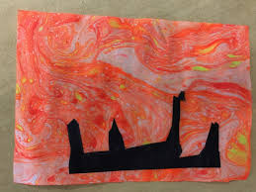  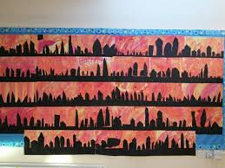  Recap on drawing techniques- children could draw houses for Class art scape.  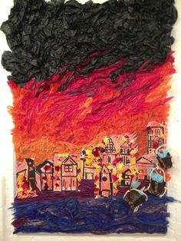 | Explore Hot air balloon collage-  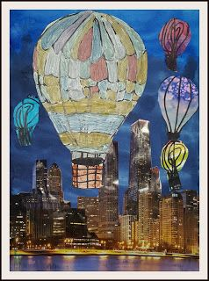  Children to create hot air balloon collages from pictures of Lancaster and painted hot air balloons.  Link to Chaz Jacobs  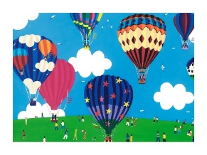  Enjoy discovering the interplay between materials for example wax and watercolour see example:  wax resist balloon/ leaf  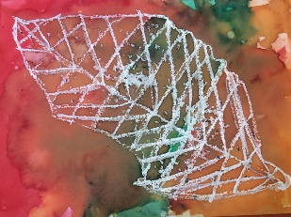  Apply this to hot air balloons drawings.  Explore simple printmaking.  For example using plasticine, found materials or quick print foam, plasticine printmaking or everyday printmaking  Search out found objects to be used as tools to press into plasticine to create texture and to understand notions of positive and negative.  Use rollers or the backs of spoon to create pressure to make a print.  Explore pattern, line, shape and texture.  Take rubbings of tress and impressions of leaves around school.  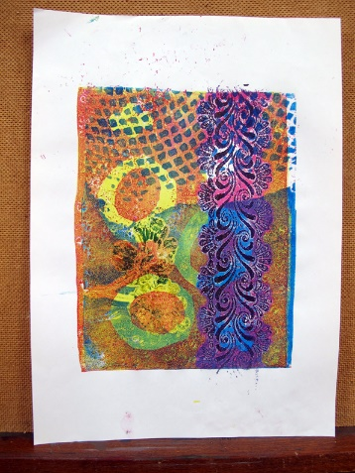  Use print materials to print a fantasy vehicle. |  |  | Explore, discover and invent ways for 2d to transform into 3d sculpture. This might be through creating drawings or prints on paper which are then folded, through collage which becomes relief, through 2d shapes which are cut out and constructed with.  For example making birds  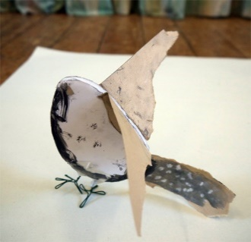  Explore modelling materials such as Modroc, clay and plasticine in an open-ended manner, to discover what they might do. modroc plasterboard or making modroc sculpture  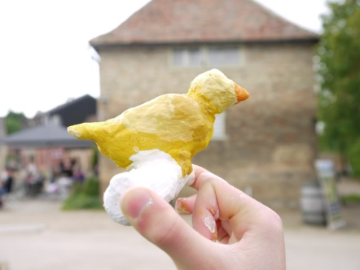  Create a plasticine bird.
PI |  | Christmas Makes  Children create silhouette Christmas cards with washed backdrop and chosen black Christmas silhouette.  Chalk and glue drawing | Mother’s Day  Create Mother’s Day card- weaving card with various material  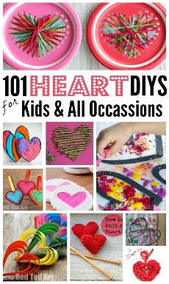  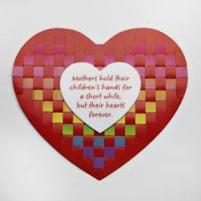 |  |  | Father’s Day Balloon with picture of child in- The Sky’s The Limit  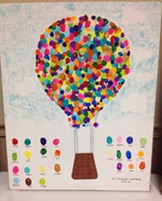
Can I Skills | Can I try to draw what I see by looking carefully?  Can I make marks, signs and symbols on a variety of types of paper with the media offered?  Can I explore tone using different grades of pencil, pastel and chalk?  Can I work spontaneously and expressively using marks, lines and curves?  Can I press down at different strengths? | Can I select and use different brushes to explore different marks?  Can I investigate mark-making using different brushes for particular effects?  Can I investigate and experiment with colour to show the effect I want?  Can I apply paint to make a background? | Can I select with thought, different materials from the teachers resources, considering content, shape, surface and texture?  Can I select organise and use materials such as threads, cottons, wool, raffia, paper strips and natural fibres to make a simple craft product? |  | Can I explore and create patterns and textures with an extended range of found materials - e.g. sponges, leaves, fruit, ink pads?  Can I apply ink to a shape or surface to experiment with printing They can use hands, feet, shapes, objects and found materials?  Can I Monoprint by marking onto an ink block, or drawing onto the back of paper on an inked block.  Can I take rubbings from texture to understand and inform my own texture prints? | Can I handle and manipulate rigid and malleable materials such as plasticine/ card and found objects to represent something familiar?  Can I feel, recognise and control surface experimenting with basic tools on rigid / pliable materials?  Can I experiment with using 2D shapes to make a 3D model?
Key Assessment | Teachers should consider assessment as a holistic practice, which takes place during every art lesson through conversation with pupils:  - Tell me about what you are making  - What might you do next?  - Tell me about what you have made  Remember! “Creativity is a fragile process that is hard to measure and assess and should always be nurtured and supported”

Y2 | Formal |  |  | Experiential
Outcomes | Each child should:  - Know how to Recognise and describe some simple characteristics of different kinds of art, craft and design  - Know the names of tools, techniques and formal elements  - Know that different forms of creative works are made by artists, craftspeople, and designers from all cultures and times, for different purposes  Be able to talk about the materials, techniques and processes they have used, using an appropriate vocabulary |  |  | Each child should be given the opportunity to:  - Discover that art is subjective (we all have our own legitimate understanding)  - Begin to feel confident to express a preference in….  - Experience the connection between brain, hand and eye  - Understand ideas can come through hands-on exploration  - Begin to build knowledge of what different materials and techniques can offer the creative individual  Work at different scales, alone and in groups
Generating Ideas | By Looking & Talking Through Making  Enjoy looking at artwork made by artists, craftspeople, architects and designers, and finding elements which inspire.  Look at a variety of types of source material and understand the differences: including images on screen, images in books and websites, art work in galleries and objects in museums.  Be given time and space to engage with the physical world to stimulate a creative response (visiting, seeing, holding, hearing), including found and manmade objects.  Develop questions to ask when looking at artworks and /or stimulus:  • Describe what you can see.  • Describe what you like? Why?  • How does it make you feel?  - What would you like to ask the artist?  Generate ideas through exploration of materials, building an understanding of what each material can do, how it can be constructed, being open during the process to unexpected ideas.
Sketch  book Focus | Develop a “sketchbook habit”, using a sketchbook as a place to record individual response to the world.  Sketchbooks to be used to show process- generation of design, make, evaluation. Also to be used for imagination at other times.  Begin to feel a sense of ownership about the sketchbook.  Practice and develop sketchbook use, incorporating the following activities: drawing to discover, drawing to show you have seen, drawing to experiment, collecting, sticking, writing notes…
 | Autumn |  | Spring |  |  | Summer
NC Link | Gun Powder Plot | South Africa | Lovely Lancaster |  | Dinosaur Hunters | Survival | Humphry Carpenter
Focus | Drawing | Colour | Collage |  | Digital Media | Printmaking
Coverage | Develop mark-making skills through experimentation with various drawing media: pencil, graphite, chalk, soft pastel, wax and charcoal. Guide to drawing materials  Explore a variety of drawing starting points (stimuli), including close looking via observation from primary & secondary source material, drawing from memory and imagination. These might include figurative, still life and landscape subject matter for drawings.  Plants drawings with range of medias.  Autumnal still lifes.  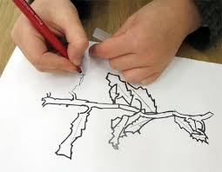  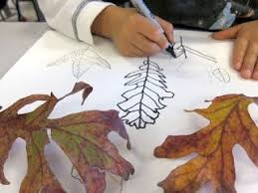 | Continue to Mix colours experientially, understanding relationships of primary and secondary colours and apply colour mixing skills to a project – producing a seasonal image of the four seasons.  Explore painting on different surfaces such as fabric and different scales.  Use new colour mixing knowledge and transfer it to other media, e.g soft pastel.  Use new colour mixing knowledge and transfer it to other media, e.g.soft pastel colour mixing in drawing project  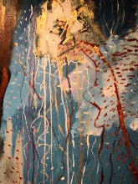  or plasticine painting with plasticine  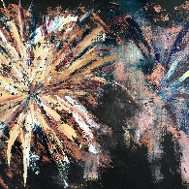  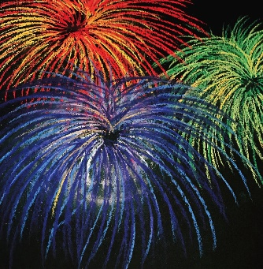  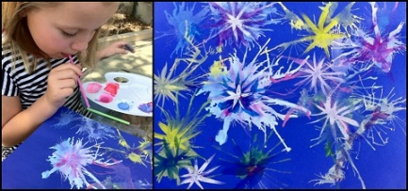 | Create a landmark of Lancaster using fabric collage techniques and sewing detail. |  | Digital Media (Sculpture):  Explore how 2D can become 3D through design through making. Look at ice sculpture artists.  Half Term Home Project: Cut simple shapes from card and use to construct dinosaur and turn into a 3D scene. Use drawn, collaged and printed elements as surface decoration. Use digital media to create records of models of the scene on return to school. | Explore simple mono-printing techniques and use drawing and printing to create an image of The Titanic, adding colour with oil pastels.
PI |  | Painting with Icing and Egg tempura to create Christmas snowflakes and cookies.  Could do Wax resist Christmas Card  Christmas tree Clay pinch pot- Link to 3D  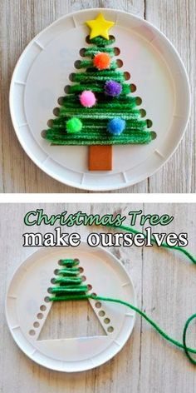  Christmas tree stitching.  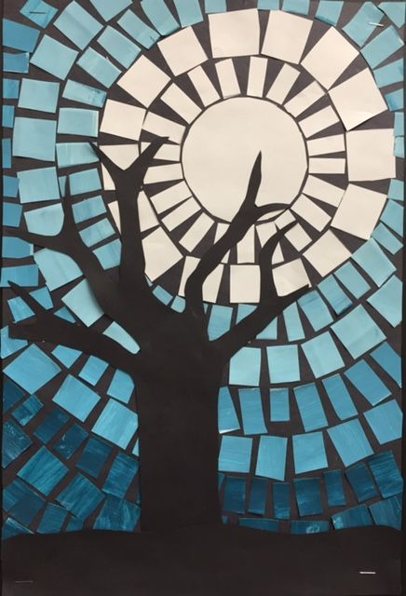  Winter scene mosaic | Art project- Children create feathers and take picture-  Mother’s Day- You Give Me Wings picture card.  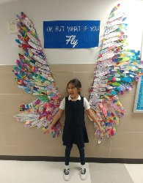 |  | 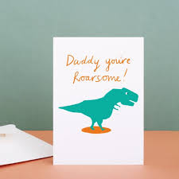 Digital picture of dinosaur and add on card.
 | Can I draw carefully in line from observation, recording shapes and positioning marks/features with some care?  Can I make quick line and shape drawings from observation adding light/dark/tone, colour and features?  Can I use line to represent objects seen, remembered or imagined working spontaneously and expressively? | Can I mix and apply colour for purposes to represent real life, ideas and convey mood  Can I use tone to represent things I see?  Can I layer paint to show different services?  Can I cut threads and fibres, stitch, sew together and surface decorate using adhesive and bead or buttons? | Can I Monoprint by marking onto an ink block, or drawing onto the back of paper on an inked block,  Can I control the pressure to improve the quality of the image?  Can I control placement of the image to give a clear print?  Can I sort, select and control colour, line, shape, texture to make and control fabric and textile surfaces from the study of a craft artist? |  | Can I select, sort and modify by, cutting, tearing with care before adding other marks and colour to represent an idea?  Can I select with thought, different materials from the teachers resources, considering content, shape, surface and texture?  Can I sort and use according to specific qualities, e.g. warm, cold, shiny, smooth  Can I engage in more complex activities, e.g. control surface decoration of materials with clear intentions?  Can I collect, deconstruct, discuss and use fabrics and cloth to reassemble new work? | Can I model with materials and control form to assemble basic shapes or forms e.g. bodies/heads and add surface features?  Can I handle and manipulates rigid and malleable materials such as clay?  Can I feel, recognise and control surface experimenting with basic tools on rigid / pliable materials?
Key Assessment | Teachers should consider assessment as a holistic practice, which takes place during every art lesson through conversation with pupils:  - Tell me about that you are making  - What might you do next?  - Which materials might you use?  - What have you discovered?  - Tell me about what you have made  - What would you like to explore more of?  Remember! “Creativity is a fragile process that is hard to measure and assess and should always be nurtured and supported”

Key Stage 2
DfE Key Stage 2
Pupils should be taught to develop their techniques, including their control and their use of materials, with creativity, experimentation and an increasing awareness of different kinds of art, craft and design.

Pupils should be taught:
- to create sketch books to record their observations and use them to review and revisit ideas
- to improve their mastery of art and design techniques, including drawing, painting and sculpture with a range of materials (e.g. pencil, charcoal, paint, clay)
about great artists, architects and designers in history.

Key Stage 2 Vocabulary / Resources
media |  | tools | application | other key vocab
newclay | charcoal | brush | blending | shape
paper | pencils | fingers | strokes | tone
card | graphite sticks | hands | layers | pattern
materials | pastels | rollers | sketch | movement
plasticine | chalk | easiprint | stencil | fluent
wood | wax crayons | lino cutters | collage | space
wire | conté pencils/sticks | sticks | paint | line
plastics | pastels | sponge | draw | colour
leather | coloured pencils | rollers | reconstruct | technique
wood | ball point pens | spatulas | dissect | craft
metal | oil pastels | house hold | drip | sculpture
mod-roc | water soluble pastels | cotton buds | splash | three dimensional
salt dough | felt pens | scissors | draw | tactile
plaster of paris | hard and soft rubber | natural | weave | functional
fabric | watercolour tempera (block and ready-mix), | man-made | build | decorative
willow | additives such as salt, sawdust, sand | clay tools | stack | motif
tempura | natural dye | viewfinders | coil | scale
foamboard | pva glue |  | assemble/ make | quantity
foamboard | water based paint |  | model/ represent | size
felt | hessian |  | print | proportion
cotton | ink |  | monoprint | observational
embellishing materials | foil |  | rub | figurative
threads | various paper and card |  | impression | texture
sculpey clay |  |  | cut | experiential
 |  |  | tear | form
 |  |  | stick | space
https://www.nsead.org/resources/curriculum/the-national-curriculum-in-england/glossary/ |  |  | collage | digital
 |  |  | resist | visual
 |  |  | wash | still life
 |  |  | embellish | pace
 |  |  | relief | exploration
 |  |  | collograph | artforms
 |  |  | motif | emotion
 |  |  | positive | imagination
 |  |  | negative
 |  |  | collect
 |  |  | write

Y 3 | Formal |  | Experiential
Outcomes | Each child should:  - Know the names of tools, techniques and formal elements (in pink above and below)  - Know that different forms of creative works are made by artists, craftspeople, and designers from all cultures and times, for different purposes. Be able to know and describe the work of some artists, craftspeople, architects and designers, including artists who are contemporary, female, and from various ethnicities  - Be able to talk about the materials, techniques and processes they have used, using an appropriate vocabulary  Be able to demonstrate how to safely use some of the tools and techniques they have chose to work with |  | Each child should be given the opportunity to:  - Discover that art is subjective (we all have our own legitimate understanding)  - Experience the connection between brain, hand and eye  - Understand ideas can come through hands-on exploration  - Develop their knowledge of what different materials and techniques can offer the creative individual  - Work at different scales, alone and in groups  - Feel safe enough to take creative risks and follow their intuition (fed with skills knowledge)  Share their journey and outcomes with others. Feel celebrated and feel able to celebrate others
Generating Ideas | Enjoy looking at artwork made by artists, craftspeople, architects and designers.  Discuss artist’s intention and reflect upon your response.  Look at artforms beyond the visual arts: literature, drama, music, film etc and explore how they relate to your visual art form.  Look at a variety of types of source material and understand the differences.  Be given time and space to engage with the physical world to stimulate a creative response (visiting, seeing, holding, hearing), including found and manmade objects.  Develop questions to ask when looking at artworks and /or stimulus:  • Describe what you see  • What do you like/dislike? Why  • What is the artist saying to us in this artwork?  • How does it make you feel?  How might it inspire you in making your own art? Use growing knowledge of how materials and medium act, to help develop ideas. Continue to generate ideas through space for playful making.  Explore how ideas translate and develop through different medium (i.e. a drawing in pencil or a drawing in charcoal). Use digital media to identify and research artists, craftspeople, architects and designers.
Sketch book | Continue to develop a “sketchbook habit”, using a sketchbook as a place to record individual response to the world.  Begin to feel a sense of ownership about the sketchbook, which means allowing every child to work at own pace, following own exploration  Practice and develop sketchbook use, incorporating the following activities: drawing to discover, drawing to show you have seen, drawing to experiment, exploring colour, exploring paint, testing ideas, collecting, sticking, writing notes, looking back, thinking forwards and around…
NC Link | Autumn |  | Spring |  | Summer
 | History-  The Victorians  Work, leisure and charity | Geography- Rivers | History-  Changes in Britain from the Stone Age to the Iron Age |  | History-  A study of the achievements of  the earliest civilisations – an overview
Focus | Printing | Colour | Collage | Drawing | 3D and sculpture
Coverage | Exploring etching and engraving using foil and rubbers to create a Celtic pattern.  Vincent Van Gogh – Starry Night (Printed Christmas card)  Weaving fabrics  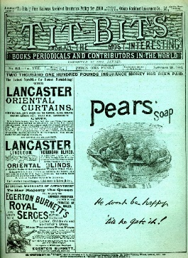  Continue to familiarize with sketchbook / drawing exercises. Let children describe how to undertake the ones they know as means of recap/reminder and introduce new ones, which are practiced regularly. Drawing exercises  Make larger scale drawing from observation and imagination. Children to draw from observation of Morris print and then create own. Use of previous colour learning to enhance. 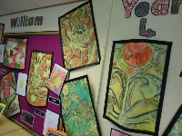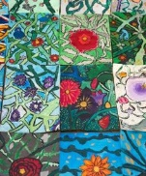 | Children to create a piece of art through weaving and fabric to represent the colours of rivers- calendar home or decoration.  Abstract artwork to express feelings – a class mountain painting.  Collage:  Creating an embellished collage of their mother for Mothers’ day cards and a decorative tile using different pattern, texture and shape  Abstract artwork to express feelings – a class mountain painting. | Creating an embellished collage of their mother for Mothers’ day cards and a decorative tile using different pattern, texture and shape | Quentin Blake style observational drawing.  Mixing colours and use of watercolours –3D digital Art making drawings move linked to Charlie and the Chocolate Factory | Clay Fruit tiles based on Mayan Patterns
PI |  | Jackson Pollock Chistmas tree ornaments  CD weaving project. Children to weave choosing colours and fabrics that remind them rivers for calendar home. | Mothers Day Collage card 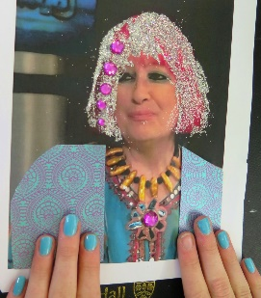  Mothers Day focus using-  Andrew Logan as Prompt. |  | Pop Art- Father’s Day card  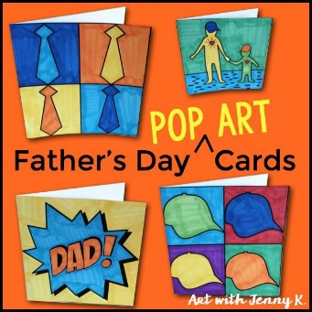
Can I Skills | Can I use a viewfinder to select a view and visual clues in an image, then record what is in the frame?  Can I use and manipulate a range of drawing tools with control and dexterity applying teacher guidance?  Can I explore shading, using different media to achieve a range of light and dark tones, black to white?0 | Can I understand how artists use warm and cool colour using this when mixing paint to express a mood?  Can create a painting from designs and research to communicate an idea or emotion  Can mix and use primary and secondary colours with the addition of black and white and other hues?  Can I use different types of brushes for specific purposes?  Can I explore the effect on paint of adding water, glue, sand, sawdust and use this in a painting?  Can I weave paper and found materials to represent an image e.g landscape, pattern or texture? | Can I explore lines, marks and tones through monoprinting on a variety of papers to create an image?  Can I understand what a negative and positive print are?  Can compare own design and pattern making with that of well-known designers or familiar patterns?  Can I print on fabric using a monoprint block or tile, or as part of a group using a simple stencil? | Can I improve skills of overlapping and overlaying to place objects in front and behind?  Can I experiment with creating mood, feeling, movement and areas of interest using different media? | Can I create textured surfaces using rigid and plastic materials and a variety of tools?  Can I design a complex pattern made up from two or more motifs and print a tiled version?  Can I sue materials and tools to good effect for connecting 2D forms?  Can I use a short blast digital camera top create movement?
Key Assessment | Teachers should consider assessment as a holistic practice, which takes place during every art lesson through conversation with pupils:  - Tell me about that you are making and what inspired you  - What might you do next?  - Tell me about the materials and techniques you are using  - What have you discovered?  - How do you feel about the end result?  - What kinds of problems did you encounter and how did you get round them?  - Tell me about things you really liked or enjoyed  - What would you like to explore more of?  Remember! “Creativity is a fragile process that is hard to measure and assess and should always be nurtured and supported”

 | Formal |  | Experiential
Outcomes | Each child should:  - Know the names of tools, techniques and formal elements (in pink above and below)  - Know about and describe some of the key ideas, techniques and working practices of a variety of artists, craftspeople, architects and designers from all cultures and times, for different purposes. Be able to know and describe the work of some artists, craftspeople, architects and designers, including artists who are contemporary, female, and from various ethnicities  - Be able to talk about the materials, techniques and processes they have used, using an appropriate vocabulary  Be able to demonstrate how to safely use some of the tools and techniques they have chose to work with |  | Each child should be given the opportunity to:  - Discover that art is subjective (we all have our own legitimate understanding)  - Experience the connection between brain, hand and eye  - Understand ideas can come through hands-on exploration  - Develop their knowledge of what different materials and techniques can offer the creative individual  - Work at different scales, alone and in groups  - Feel safe enough to take creative risks and follow their intuition (fed with skills knowledge)  Share their journey and outcomes with others. Feel celebrated and feel able to celebrate others
Generating Ideas | Enjoy looking at artwork made by artists, craftspeople, architects and designers.  Discuss artist’s intention and reflect upon your response.  Look at artforms beyond the visual arts: literature, drama, music, film etc and explore how they relate to your visual art form.  Look at a variety of types of source material and understand the differences.  Be given time and space to engage with the physical world to stimulate a creative response (visiting, seeing, holding, hearing), including found and manmade objects.  Develop questions to ask when looking at artworks and /or stimulus:  • Describe the artwork.  • What do you like/dislike? Why?  • Which other senses can you bring to this artwork?  • What is the artist saying to us in this artwork?  • How might it inspire you to make your own artwork?  • If you could take this art work home, where would you put it and why?  Take part in small scale crits throughout so that brainstorming becomes part of the creative process. Use growing knowledge of how materials and medium act, to help develop ideas. Continue to generate ideas through space for playful making.  Explore how ideas translate and develop through different medium (i.e. a drawing in pencil or a drawing in charcoal). Use digital media to identify and research artists, craftspeople, architects and designers.
Sketch Book | Continue to develop a “sketchbook habit”, using a sketchbook as a place to record individual response to the world.  Begin to feel a sense of ownership about the sketchbook, which means allowing every child to work at own pace, following own exploration  Practice and develop sketchbook use, incorporating the following activities: drawing to discover, drawing to show you have seen, drawing to experiment, exploring colour, exploring paint, testing ideas, collecting, sticking, writing notes, looking back, thinking forwards and around, reflecting, making links…
NC Link | Autumn |  |  | Spring |  | Summer
 | History-  Tudors and Stuarts  Rebellion and Revolution | Lancashire Witches – Trials of 1612 |  | Hist/ Geog- Italy  The Roman Empire and its impact on Britain |  | History-  A study of the achievements of the earliest civilisations – a depth study:  Ancient Egypt
Focus | Drawing | Colour |  | Printmaking | Collage/ Craft | 3D/ Scultpure
Coverage | Use growing technical skill and knowledge of different drawing materials, combined with increasing confidence in making a creative response to a wide range of stimuli, to explore more experimental drawing, following child’s own interests/affinities  Continue to familiarize with sketchbook / drawing exercises. Describe how to undertake the ones they know as means of recap/reminder and introduce new ones, which are practiced regularly.  Study the work of Holbein and Henry 8th Court – Art appreciation, discussion of portraits, looking at the use of symbolism in artwork linked to Tudors.  Use sketching skills to draw themselves, using the style of Holbein.  Use watercolour wash for printed Christmas cards. | Create a one-off project Christmas consolidating old skills and introducing new skills (including: creating spaces and places in sketchbook to help creative thinking, exploring and revealing own creative journey from a shared starting point of  Self-portraits in the style of Holbein for Calendar.  Foam board Christmas stars  Felt Christmas trees |  | Combine artforms such as collage, painting and printmaking in mixed media projects to recreate an Italian painting in the style of Henri Matisse  Investigate the work of Roy Lichtenstein and use his style to create artwork of our own. Mothers’ Day cards |  | Make a figure from paper and tape and use as the basis to explore modelling with Modroc to make mummies.  Paint final piece.  Children make coil pots- an Egyptian skill.  1 - Explore modelling with clay to make shabti.  Paint final piece.  2 - Children make coil pots- an Egyptian skill.  3-Ann Lewis – Lino prints – fathers’ day cards
PI |  | Christmas  Add Christmas Artwork piece onto Christmas card to send home.  Self Portraits in style of Holbein for calendar  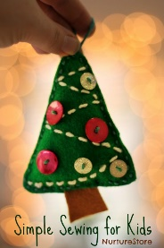  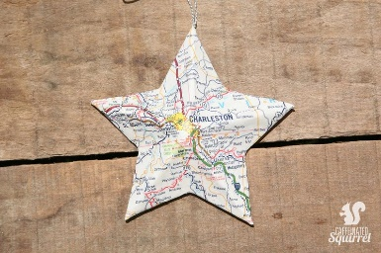  Use foam board and map of their home location to create a Christmas decoration. |  | Matisse Mother’s Day card- Children collage and print images that remind them of their mother. |  | Look at the Linocuts of Anne Lewis as examples.  Use roller and lino print to create picture print for card.  Apply to father’s day card.  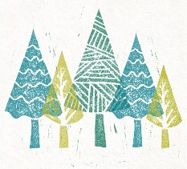
Can I skills | Can I use line, tone, shape and mark with care to represent things seen, imagined or remembered?  Can draw in line with care when taking a line for a walk, or in scale applying rules of simple perspective?  CanI make quick studies from observation to record action or movement with some fluency?  Can draw with coloured media descriptively and expressively to represent ideas and objects with increasing accuracy/fluency? | Can I represent things observed, remembered or imagined, using colour selecting appropriate paint and brushes?  Can I attach different elements using stitching, using straight stitch, running or cross-stitch (craft obj)? |  | Can I cut multiple shapes with a scissors and arrange /stick these on a surface for a purpose?  Can I represent a textured image from found textures that have been selected? | Can I explore colour mixing, printing, using two coloured inks a roller and stencil or pressprint. | Can I identify and assemble found materials to make a new form, carefully covering with ModRoc or papier maché?  Can I construct a structure in linear or soft media before then covering the surface to make a form?  Can build in clay a functional form using two/three building techniques and some surface decoration?
Key Assessment | Teachers should consider assessment as a holistic practice, which takes place during every art lesson through conversation with pupils:  - Tell me about that you are making and what inspired you  - What might you do next?  - Tell me about the materials and techniques you are using  - What have you discovered?  - How do you feel about the end result?  - What kinds of problems did you encounter and how did you get round them?  - Tell me about things you really liked or enjoyed  - What would you like to explore more of?  Remember! “Creativity is a fragile process that is hard to measure and assess and should always be nurtured and supported”

Y5 | Formal |  |  | Experiential
Outcomes | Each child should:  - Know the names of tools, techniques and formal elements (in pink above and below)  - Research and discuss ideas and approaches of range of artists, craftspeople, architects and designers from all cultures and times, for different purposes. Be able to know and describe the work of some artists, craftspeople, architects and designers, including artists who are contemporary, female, and from various ethnicities  - Be able to talk about the materials, techniques and processes they have used, using an appropriate vocabulary. Describe processes used and how they hope to achieve high quality outcomes  Be able to demonstrate how to safely use some of the tools and techniques they have chose to work with |  |  | Each child should be given the opportunity to:  - Discover that art is subjective (we all have our own legitimate understanding)  - Experience the connection between brain, hand and eye  - Understand ideas can come through hands-on exploration  - Develop their knowledge of what different materials and techniques can offer the creative individual  - Work at different scales, alone and in groups  - Feel safe to take creative risks and follow their intuition (fed with skills knowledge) and define their own creative journey  Share their journey and outcomes with others. Feel celebrated and feel able to celebrate others.
Generating Ideas | Enjoy looking at artwork made by artists, craftspeople, architects and designers.  Discuss artist’s intention and reflect upon your response.  Look at art forms beyond the visual arts: literature, drama, music, film etc and explore how they relate to your visual art form.  Look at a variety of types of source material and understand the differences.  Be given time and space to engage with the physical world to stimulate a creative response (visiting, seeing, holding, hearing), including found and manmade objects.  Develop questions to ask when looking at artworks and /or stimulus:  • Describe the artwork.  • What do you like/dislike? Why?  • Which other senses might you bring to this artwork? How does it make you feel?  • What is the artist saying to us in this artwork?  • How might it inspire you to make your own artwork?  • Who or what else might you look at to help feed your creativity?  Take part in small scale crits throughout so that brainstorming becomes part of the creative process. Use growing knowledge of how materials and medium act, to help develop ideas. Continue to generate ideas through space for playful making.  Explore how ideas translate and develop through different medium (i.e. a drawing in pencil or a drawing in charcoal). Use digital media to identify and research artists, craftspeople, architects and designers.  Use camera phones (still and video) to help ”see” and “collect” (digital sketchbook).
Sketchbook Focus | Continue to develop a “sketchbook habit”, using a sketchbook as a place to record individual response to the world  Begin to feel a sense of ownership about the sketchbook, which means allowing every child to work at own pace, following own exploration.  Increasingly see the sketchbook as a place which raises questions which can be explored/answered outside the sketchbook, so that the link between sketchbook and journey and outcome becomes understood.  Practice and develop sketchbook use, incorporating the following activities: drawing to discover, drawing to show you have seen, drawing to experiment, exploring colour, exploring paint, testing ideas, collecting, sticking, writing notes, looking back, thinking forwards and around, reflecting, making links…
NC Link | World War I  (overview of causes and key events) | Lancaster’s role during the Great War, and the impact of it on the city |  | Geog- Link to The Coast |  | Ancient Greece – a study of Greek life and achievements and their influence on the western world.
 |  |  |  | Viking
Focus | Printing
Coverage | Exploring the work of Bridget Wilkinson, looking at colour and her coastal paintings, recreating and designing our own using the local area for inspiration  Printing  Victorian printing in the style of Liberty Prints and Morris prints | Using the prints to create stockings (DT link) |  | Drawing  Exploring the relationship of line, form and colour to create Viking inspired drawings. | Collage/Craft  Studying the work of Carolyn Saxby to create a textile collage with texture | 3D-Sculpture  Create 3D sculptures based on Greek Gods and Goddesses
PI | 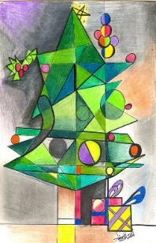 Cubism Christmas Card  http://elementary-art-rocks.blogspot.com/2014/01/grade-4-radial-designs.html  Aztec Art Radial designs- Calendar. |  |  |  | Look at works of Carolyn Saxby  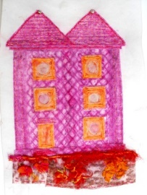  Combine elements to create Textile collage with texture- Coast | Fathers Day card-  Children to recreate different ‘dad’ still life poses and add to card.  Or add picture of dad to card with reduced image of themselves with- I look up to You, slogan.  Could create pop out on page.
Can I skills | Can I select ,use and manipulate a range of drawing tools, using them with control and dexterity to accurately represent from observation  Can I and compile and develop several studies as visual evidence for a purpose?  Can I develop quick studies from observation recording action and movement with fluency? |  | Can I create different effects by using a variety of tools and techniques such as dots, scratches and splashes, and applying paint in layers?  Can convey tonal qualities well, showing good understanding of light and dark on form?  Can I plan/paint symbols, forms, shapes, and composition when exploring the work of other artists/cultures informing their painting? | Can I explore colour mixing through printing, using two coloured inks a roller and stencil Easiprint poly-blocks  Can I design a complex pattern made up of two motifs and print a tiled version? | Can I make connections between own work and patterns in their local environment (e.g. curtains, wallpaper)?  Can select and use cutting tools and adhesives with care to achieve a specific outcome?  Can select and use found materials with art media and adhesives to assemble and represent a surface or thing  Can I select and use contrasting colours and textures in stitching and weaving? | CanI explore how a stimuli can be used as a starting point for 3D work with a particular focus on form, shape, pattern, texture, colour?  Can I recreate 2D images in 3D, looking at one area of experience, e.g. recreate a landscape or figure focusing on form/ surface?
Key Questions | Assessment Questions  Teachers should consider assessment as a holistic practice, which takes place during every art lesson through conversation with pupils:  - Tell me about that you are making and what inspired you  - What might you do next?  - Tell me about the materials and techniques you are using  - What have you discovered?  - How do you feel about the end result?  - What kinds of problems did you encounter and how did you get round them?  - Tell me about things you really liked or enjoyed  - What would you like to explore more of?  - What is the potential of what you have done? What could you do next?  Remember! “Creativity is a fragile process that is hard to measure and assess and should always be nurtured and supported”

Y6 | Formal |  | Experiential
Outcomes | Each child should:  - Know the names of tools, techniques and formal elements (in pink above and below)  - Be happy to describe, interpret and explain the work, ideas and working practices of artists, craftspeople, architects and designers from all cultures and times, for different purposes. Be able to know and describe the work of some artists, craftspeople, architects and designers, including artists who are contemporary, female, and from various ethnicities  - Be able to talk about the materials, techniques and processes they have used, using an appropriate vocabulary. Describe processes used and how they hope to achieve high quality outcomes  Be able to demonstrate how to safely use some of the tools and techniques they have chose to work with |  | Each child should be given the opportunity to:  - Discover that art is subjective (we all have our own legitimate understanding)  - Experience the connection between brain, hand and eye  - Understand ideas can come through hands-on exploration  - Develop their knowledge of what different materials and techniques can offer the creative individual  - Work at different scales, alone and in groups  - Feel safe to take creative risks and follow their intuition (fed with skills knowledge) and define their own creative journey  Share their journey and outcomes with others. Feel celebrated and feel able to celebrate others
Generating Ideas | Enjoy looking at artwork made by artists, craftspeople, architects and designers. Discuss artist’s intention and reflect upon your response.  Look at artforms beyond the visual arts: literature, drama, music, film etc and explore how they relate to your visual art form.  Look at a variety of types of source material and understand the differences.  Be given time and space to engage with the physical world to stimulate a creative response (visiting, seeing, holding, hearing), including found and manmade objects.  Develop questions to ask when looking at artworks and /or stimulus:  • Describe the artwork.  • What do you like/dislike? Why?  • Which other senses might you bring to this artwork? How does it make you feel?  • What is the artist saying to us in this artwork?  • How might it inspire you to make your own artwork?  • Who or what else might you look at to help feed your creativity?  Take part in small scale crits throughout so that brainstorming becomes part of the creative process. Use growing knowledge of how materials and medium act, to help develop ideas. Continue to generate ideas through space for playful making.  Explore how ideas translate and develop through different medium (i.e. a drawing in pencil or a drawing in charcoal). Use digital media to identify and research artists, craftspeople, architects and designers.  Use camera phones (still and video) to help ”see” and “collect” (digital sketchbook).
Sketchbook Focus | Continue to develop a “sketchbook habit”, using a sketchbook as a place to record individual response to the world.  Begin to feel a sense of ownership about the sketchbook, which means allowing every child to work at own pace, following own exploration.  Increasingly see the sketchbook as a place which raises questions which can be explored/answered outside the sketchbook, so that the link between sketchbook and journey and outcome becomes understood.  Practice and develop sketchbook use, incorporating the following activities: drawing to discover, drawing to show you have seen, drawing to experiment, exploring colour, exploring paint, testing ideas, collecting, sticking, writing notes, looking back, thinking forwards and around, reflecting, making links…
NC Link | Autumn |  | Spring |  | Summer
 | History-  World War Two | History-  The building of wealthy Georgian Lancaster (African-American artist/ Slavery link) | History- Early Britain Recap  Science- Electricity |  | PSHE- Transition
Focus | 3D  Design & Making | Drawing | Collage/ Craft | Printing | Printing | 3D Design
Coverage | Research into Diane Komater to learn the skill of wire sculpture. This is in relation to our topic and class novel.  Christmas card  Children to use a compass to create a circles to form a christmas tree | Seasonal calender  Life drawing of seasonal plants/tress iconic for each season  Scalp clay tree decorations  Collage christmas card | Children to use collage to create a portrait picture. Using colour, black and white and looking for expression and detail.  . | Children will use tie dye to create a design on the front of a t-shirt |  | Children create a treasure box to take home that has their favourite memories of school.  https://www.accessart.org.uk/treasure-box-by-kelly-richards/  Children to create and make some props using 3D skills.
PI |  | Marbling Tree Ornaments-  https://sisoo.com/2015/12/10/how-to-marble-christmas-tree-ornaments/  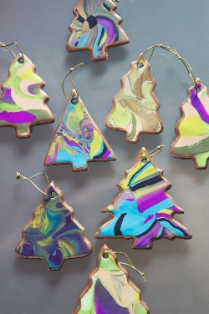 | Mothers Day Sewing Circuits  Sewing circuits using to create a light up picture for mothers-day. |  | Father’s Day Card- Revise previous skills.  Children to create splash art/ apply various colours to paper.  Create card and draw lettering.  Using paper craft knives to cut lettering and add to card.  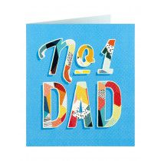
Can I skills | Can I accurately select appropriate media and techniques to achieve a specific outcome?  Can I select a view and use a viewfinder to record what is in the frame?  Can I develop quick studies from observation recording action and movement with fluency, returning to each study to improve accuracy/detail?  Can I confidently use charcoal/pastels in response to light and dark, shadows and well lit areas? | Can I select from different methods to apply colour using a variety of tools and techniques to express mood or emotion?  Can use studies gathered from observation to help plan and realise paintings, using thumbnail studies and paint techniques to represent action or interaction?  Can I show the effect of light and colour, texture and tone on natural and man-made objects? (Spring 1) | Can I embellish a surface using a variety of techniques, including drawing, painting and printing?  Can I embellish decoratively using more layers of found materials to build complexity and represent the qualities of a surface or thing?  Can I build up drawings and images of whole or parts of items using various techniques, e.g. card, relief, found materials, torn and cut materials? | Can I recreate images through relief printing using card and mark making tolls to control, line, shape, texture and tone  Can design prints for e.g. fabrics, book covers, wallpaper or wrapping paper  Can recreate a scene and detail remembered, observed or imagined, through collage relief ‘collagraph’ printing  Can dye fabrics and use tie-dye techniques to control and create a fabric image  Can I control stitching - using various needles to produce more complex patterns with care and some accuracy? | Can I use study of 3D work from a variety of genres and cultures to develop their own response through models, experimentation and design stages?  Can I make imaginative use of the knowledge they have acquired of tools, techniques and materials to express own ideas and feelings?  Can apply knowledge of different techniques to expressive scale, weight or a concept?  Can I use plaiting, pinning, stapling, stitching and sewing techniques with care to decorate and make an image or artefact? (craft skill)
Key Questions | Assessment Questions  Teachers should consider assessment as a holistic practice, which takes place during every art lesson through conversation with pupils:  - Tell me about that you are making and what inspired you  - What might you do next?  - Tell me about the materials and techniques you are using  - What have you discovered?  - How do you feel about the end result?  - What kinds of problems did you encounter and how did you get round them?  - Tell me about things you really liked or enjoyed  - What would you like to explore more of?  - What is the potential of what you have done? What could you do next?  Remember! “Creativity is a fragile process that is hard to measure and assess and should always be nurtured and supported”

