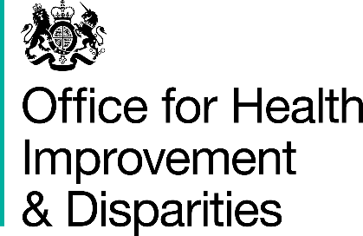

National Dental Survey, 2023 to 2024

I have read and understood the information for parents and persons with parental responsibility

I agree to my child having a dental check as part of the national dental survey for 5 year olds 2023 to 2024

Child’s name: _______________________________________________

Child’s date of birth: _________________________________________

Child’s home postcode: ______________________________________

Childs's Ethnicity:_______________________________________

Name of parent or person with parental responsibility: _____________

Signature of parent or person with parental responsibility: _________

Date:__________________________

Please return this form to your child’s school. Thank you.

