During lockdown, Showbie was used to deliver the curriculum. Teachers shared resources on Showbie, presented lessons, hosted drop in sessions, provided feedback for children and took the register on Showbie. All of the elements of a normal school day was communicated through Showbie.
Following lockdowns and school closures we have continued to use this resource on a day to day basis as part of our blended approach.
As we continue to adapt our approaches to meet the continuing ever changing climate, we have outlined how Showbie is currently used as a tool to use at home and in school. This is to help enable parents in accessing the appropriate information that is shared on Showbie to support children at home with their learning.

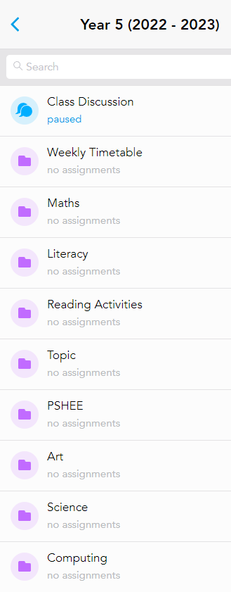

The purple folders
These folder are primarily for use in school for teachers and children to access their lessons.
All lessons and resources are uploaded to these folders on a Friday, ready for the following week.
Additionally, this also provides an opportunity for parents can keep up to date with the learning that is taking in the classroom. Discussion at home around these areas of learning before they are introduced in class, will prepare children for the lesson and strengthen their links in learning and help to embed concepts.

The green folders
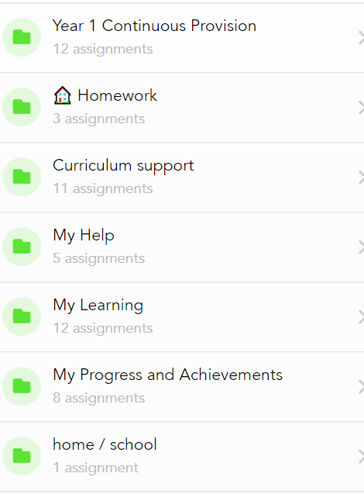
Everything that is shared in the green folders is for children and parents to access at home.

The homework folder
Just talk/chatter matters
Spellings
MyMaths
task homework

Curriculum support
5-minute curriculum overview
enrichment at home
learn it know its

My Help
passwords (for your child’s online platforms)

My Learning (you will find files in these folders if your child has an ILP – individual learning plan)
ILP (this is for the target setting ILP)
ILP activities

My progress and achievements
Awards
Evaluated ILPs
Achievement trackers (writing, reading and maths)
Report (termly)
Pupil Passports

Home / School
Show and Tell
Photographs
(staff will endeavour to respond with comments to files shared in this folder)

Tuition (you will find files in these folders if your child takes part in tuition)
Tuition activities
Tuition plan

Absences
When children are ill, and they are not well enough to be in school, they should take time to rest and recover – there is no expectation for children to access their learning on Showbie. However, if children choose to complete any work on Showbie during an absence from school, staff will endeavour respond to the work children complete on Showbie.
Where there is an agreement between home and school that a child is accessing their learning from home, through Showbie, due to medical circumstances, children need to follow the current weekly timetable and use the purple folders to find the lessons presentations and accompanying resources. The expectation would be that children complete, as a minimum, their current literacy and numeracy work. During COVID-19 lesson presentations were uploaded to Showbie with a voice recording of the teacher delivering the lesson, as we move forward, lessons will not have a voice recording. Staff in school will provide feedback on current work that is completed by children working at home in these circumstances.

