Lancashire Healthy Young People and Families Service
Unit 5a, Edward VII Quay
Navigation Way
Riversway
Preston
PR2 2YF
0300 247 0040
School Year 2022/23

Dear Parent/ Carer

The Lancashire Healthy Young People and Families Service is developing better ways to understand and support the direct care and health and wellbeing of children and young people within schools. To help us achieve this, we will be continuing to undertake the School Health Needs Assessment Programme. This allows us to assess the health and social care needs of children in Year 6.

A health needs assessment questionnaire has been designed in collaboration with the Public Health Team at Lancashire County Council for children who wish to participate in the school health needs assessment programme. The questionnaire is completed online (via the Lancashire County Council secure portal) in class, by your child, regarding their health and well-being. This can be viewed on HCRG’s website via the following link:

https://lancsyoungpeoplefamilyservice.co.uk/school-nursing/

The school health needs assessment programme provides vital information to help us improve the direct care and support for individual children and for the whole age group.

The Healthy Young People and Families Team review the completed questionnaires to identify children or families who would benefit from some support. An anonymised School report is shared with the Schools so they can understand their School’s health needs. The anonymised information from the questionnaires also allows the health team to see any common issues that might help us improve the services we provide as your child transitions into High School. Questionnaires are treated in the same way as all children’s health information and are stored confidentially in the child’s health records.

We will attempt to contact you by letter if, as a result of the questionnaire, your child wishes to speak with a nurse or if our support may be beneficial. If we don’t hear back from you at that time, we will offer initial support to your child but please be assured that we will contact you if there is anything that requires further discussion.

If you do not wish your child to complete the questionnaire or you would like to speak to your school nursing team please contact within the next 7 days on the number above:
- Option 1 - Preston and Central area
- Option 2 - North and Lancaster area
- Option 3 - Burnley and East area

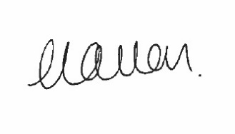
Yours sincerely

Catherine Allen
Head of Operations

