bok
What is the date today?

What will it be tomorrow?

How many months have 30 days?
How many have 31 days?
How many more days are there until the end of the month?

How many days are there until the next school holiday?
How many Saturdays are there in the month we are in?
How many months is it until your birthday?

… until Christmas?
How many days are there in the month we are in?

Calendars
What page number are you on in your book?
Is this an odd or even number?

What is the longest word you can find in your book? How many letters has it got?

What is the shortest and longest book you can find?

How many pages have they got?

How many words on this page start with a vowel?
Can you find a seven letter word in your book?

How many pages have you read so far?

Reading a book

Read the page numbers together. Can you find a number e.g. 27? … 13?

How many more pages do you need to read to finish your book?

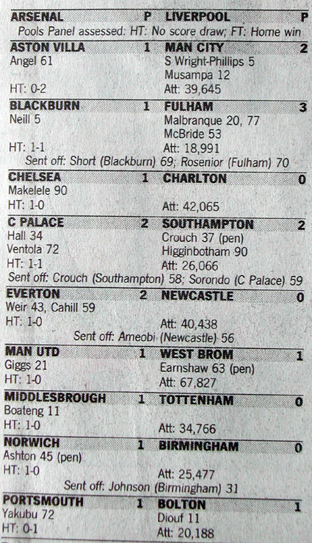
How many club cards are there? … hearts?
… diamonds?

How many picture cards (jacks, kings, and queens) are there altogether?

What is the largest number card?

How many ♦ symbols altogether are there on the all of the diamonds cards?
(look for the little ones as well)

How many ♣ symbols altogether are there on the 1,2,3,4 and 5 of clubs?
(look for the little ones as well)

Can you find 3 cards that add up to 15?
… 21? … 50?

How many cards are there altogether, including jokers?

How many red cards are there?
…black cards?

Playing Cards
Which team(s) scored the most goals?

Which game(s) had the most goals scored?

How many teams have names beginning with a vowel?

Did your favourite team score more than many other teams?

If you add all of the goals together what is the total?

What is the difference between the highest score and the lowest score?

Which team(s) scored the least number of goals?

How many teams scored:
1 goal?
2 goals?
3 goals?

Football scores
♥ ♠
♦ ♥

a
Cut your toast into quarters. How many quarters are there? Eat one piece. How many quarters are left?

Estimate how many items in a packet (e.g. biscuits). Count them. Was your estimate close?

Look at ‘best before/sell by’ dates. How many days or months before this date?

Look at some cooking times on some packets. Which takes the longest to cook? Which takes the shortest time to cook?

Find some bottles and cartons. Look at how much they hold. Sort them into more than 2 litres, between 1 and 2 litres and less then a litre.

Find some small containers. Estimate which holds the most/ least. Now use an even smaller container to measure; e.g. an egg-cup. Count how many egg-cupfuls in each container.

Find some packets and tins and look at them to find out how much they weigh. Which is the lightest? Which is the heaviest?

Kitchen
How many steps to climb to the top of the slide?
How many altogether if you climb up twice?

How many children are at the park?

How many dogs can you see?

How many whole turns can you do on the roundabout?
(without getting dizzy!)
How far are the swings from the slide? Estimate first, and then count footsteps. Compare this measurement with the distance between two other pieces of play equipment.

Ask your friends and family about their favourite piece of play equipment? Which is the most popular?

Count to 100 as you are swinging.

What shapes can you see in the park? How many triangles?
… cuboids?
… circles?

Park
Help to set the timer on a microwave to cook different items.

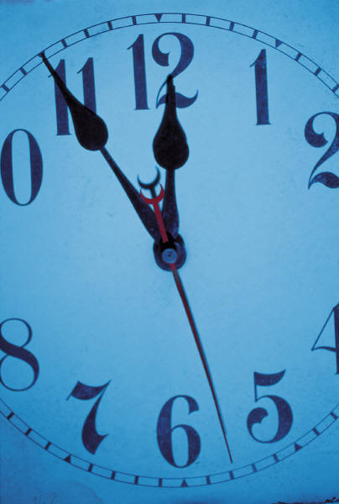
How many pages are there in the book?
How many words are there on page …?
(one with not too many)
Which page has most pictures? How many has it got?
If an ant walked from the top to the bottom of the book and back how many centimetres would it walk?
On page … how many words begin with the letter m?
Is the book heavier or lighter than your shoe?

How many words on page … begin with a vowel?
How many pictures are there on page 2?...5?
Books
How many number ones are there on the clock face?

Which number is half way round if you start at 12 o’clock?

What time is it now?
How long does it take to get from the 1 to the next number with a one in it?
How many minutes are there in one hour?

What time will it be in three hours time?

Which number is opposite the number 12?

How many hours from 3 o’clock to 9 o’clock?
Clocks

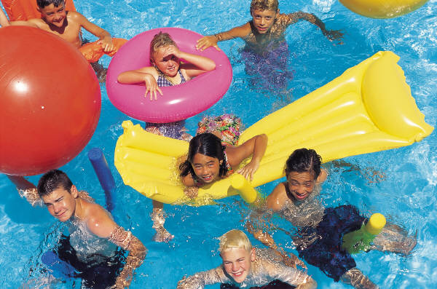
Can you put the digits in order from the smallest to largest?
(e.g. 2 6 7)

If you add the digits together what is the total?

How many digits are odd and how many are even?

What is the difference between the largest and smallest digit?

If you add 1 to each of the digits what would the number plate read now?

What about if you subtract 1 from each?

What is the largest number you could have on a number plate?

Can you find a car with a bigger/smaller number?

Can you put the digits in order from the largest to smallest?

Number Plates
About how many people are in the pool altogether?

How many lilos are there?

What shapes can you see in the building?

What’s the difference between the number of boys and the number of girls in the pool?

Are there more boys or more girls?

How long do you think the pool is?

How many are wearing swimming hats?

How many adults are on the side of the pool?

Swimming pool

: T672 AJF :

Who has got the biggest shoe in the family? How many cm long is it?

How many T-shirts do you have? Sort them by colour. How many more blue T-shirts do you have than red?

Which is longer: the legs of your trousers or the arms of your jumper? How much longer?

Look at the labels in your clothes for a waist size, chest size or height. Measure yourself to check you have the right sized clothes.

Look at the labels in your clothes. Can you find out what temperature the water should be when your clothes are washed?

Are any of your clothes symmetrical?

How many pairs of socks have you got? How many socks is that?

Shoes and clothes
What shapes can you see?
What shape is a cereal packet? What shape is a tin of beans?

Look out for the largest and smallest packets you can find. Which costs the most?

Estimate how many apples there are in the tray?

How many cartons of orange juice do you think there are on the shelf?

How many checkouts are being used? How many checkouts are not being used? How many are there altogether?

How many trolleys are there in the trolley park? How many different types of trolley are there?

How many different flavours of _____ can you see?
Which do you think is the most popular?
(more have gone)

Supermarket
Measure the zip on your jacket and an adult’s jacket. Which is longer? How much longer?

Look out for multi-packs of items. How many tubes of Polos in 2 packs? How many packs of crisps in two big packs?

What time does the shop you are going in open and close?

Can you find two things you could buy for less than £1?
Can you spot any special offers? Is anything 50% off? What does this mean?

What different shapes can you see around you?
Can you see any cubes or cylinders?
What is the cheapest thing you can see for sale?

What is the most expensive thing you can see?
How long is the shop open for today?

Shopping centre
What time did we leave school and arrive home?
How long is that?
How many lamp-pots will you pass on the way home? Check by counting.
How many turns, right or left, do you have to make to get home?
How many red cars can you count on the journey?
Can you spot any doors with odd numbers on them? … even numbers?
What is the largest odd numbered door you can see on the way?
Look at the front of a house, what shapes can you see on the windows, doors, bricks or gates.

On the walk home
Can you see a clock? What time is it?

How many pages are there in the catalogue?

What is the cheapest thing on page 52?

Can you find two things that cost more than £50 and two things that cost less than £20?

Look for the toys in the index. What pages are they on? Can you find them?

Can you use a calculator to find the cost of two items? What does the display say?

Choose a page from the toys section. Find two things you could buy for £10, £20.

Look at page 78. What is the most expensive thing on that page?

Catalogue
What is the most common car colour? How many can you count in 2 minutes?

How much does petrol cost per litre?

How much time will your journey take? Time it and see.
What is the number on your car number plate? Can you spot a car with a higher number on it?

What number do you think you can count to before the traffic lights turn green? Check to see if you are right.

Can you spot a number plate with a 3 in it? What is the whole number on the number plate?

How many cars are at the petrol station? If each car has four wheels, how many wheels are there?

Car journey

